Abstract
Visual computer simulations of natural phenomena such as clouds, water and fire has for a long time been an area for intensive research. These fluid-like motions have extremely complex behavior, and their chaotic and unpredictable motion render them into fascinating visual effects. Even though the Navier-Stokes equations describing these effects have been known for over a century, the complexity make them difficult and computationally expensive to imitate and visualize accurately. Within scientific research, Computational Fluid Dynamics (CFD) has become a widespread and cost-effective alternative to real-life experiments. These simulations often demand a high degree of accuracy, and computer engineers respond by employing parallel software and hardware techniques to obtain the required efficiency.
We present an optimized algorithm for visual simulation of smoke. The model is based on the Computational Fluid Dynamics (CFD) model presented by Fedkiw, Stam and Jensen in the paper Visual Simulation of Smoke []. Visual CFD and is analyzed with respect to efficiency, visual quality and parallelism. We target Intel based SMP (Symmetric Multi Processor) systems running MS Windows, aiming for at least 20 frames per second.
- Introduction
Early researchers in the field of visual fluid simulations produced realistic results by applying mathematically generated textures to simple geometric structures [][]. This approach did not count for interaction with solid objects and left the animators with the tedious work of parameter tweaking. Stein and Max [], among others, proposed a particle based approach for fluid simulations, where a constant number of particles were moved through the volume. Foster & Metaxas published their paper, Modeling the Motion of a Hot, Turbulent Gas[], in 1997, introducing an CFD algorithm for visual fluid simulations. They extracted the parts of Navier-Stokes' equations that affect the interesting visual features of smoke, such as convection and vorticity, thus creating a model capable of simulating realistic smoke on relatively coarse grids. Their model was only stable for small time steps because of an explicit integration scheme, and the result was animations possibly evolving slowly due to these small time steps. Stam was the first to present a stable algorithm solving the full Navier-Stokes equations [], independent of the time steps. This was achieved using a semi-Lagrangian approach together with implicit solvers, allowing for much larger time steps and a faster evolving simulation. Fedkiw et. al. [] pointed out that the first-order integration scheme used by Stam caused too much numerical dissipation and small scale details just tended to die out. Fedkiw, Stam and Jensen presented a model aiming for visual simulation of smoke, compared to the general fluid simulator of Stam. Their model was based on the work of Foster & Metaxas[] and Stam [], but featured some modifications for improved visual quality.
The models and algorithms presented in [][][], all demonstrate a clear evolution within visual simulations of fluids. Stam implemented a version that "allows an animator to design fluid-like motions in real time" [], while Fedkiw et al. reported frame rates ranging from 10 fps to 1 fps for their fastest, low-quality simulations.
For a real-time environment aiming for a visual imitation of the real world, these frame rates are still not sufficient. We present a configuration of parameters, sub-algorithms and numerical solvers, all analyzed with respect to visual quality, computational efficiency and parallelism, eventually aiming for frame rates of 20 and above on today's modern desktop hardware.
- The simulation model
The simulation model is based on the one presented by Fedkiw et al. [], which shares several steps with Stam[] and Foster et al. []. The algorithm uses two three-dimensional grids dicing the computational domain into identical, discrete cubes named voxels. One grid contains data for the previous frame while the other stores the data generated at the current frame. After a full frame of simulation, the grids are swapped and the algorithm loops. Each grid defines the velocity vector u, together with values such as density ρ, temperature T, and user-defined forces $f_{\text{userdefined}}$(e.g. wind).

The algorithm’s five main numerical steps:

1. Add forces
Initially, the velocity field is updated with respect to all forces. Both the buoyancy force (Eq ) and any user-defined forces are multiplied by the time step $Δt$, added up with the velocity from the previous frame, and stored in the grid for the current frame (Eq ). The buoyancy force works only in the vertical direction and accounts for both gravity, $−\text{αρ}$, and the effect of hot air rising, $T−T_{\text{amb}}$. The two constants α and β should be set up with physically realistic values.
$$u=u+Δt∗\left(f_{\text{buoy}}+f_{\text{userdefined}}\right)$$ | Eq
$$f_{\text{buoy}}=−\text{αρ}+β(T−T_{\text{amb}})$$ | Eq

2. Self-advect velocities
The smoke's velocity is described by Euler's equations, assuming that smoke can be modeled as an incompressible, inviscid fluid.
$$∇u=0$$ | Eq
$$\frac{∂u}{∂t}=−\left(u⋅∇\right)u−∇p+f$$ | Eq
f is the sum of the buoyance force (Eq ) and all user defined forces. p describes the pressure, with the gradient defined at voxel [i, j, k] as...
$$\begin{aligned}∇p_{i,j,k}^{x}=p_{i+1,j,k}−p_{i−1,j,k} \\ ∇p_{i,j,k}^{y}=p_{i,j+1,k}−p_{i,j−1,k} \\ ∇p_{i,j,k}^{z}=p_{i,j,k+1}−p_{i,j,k−1}\end{aligned}$$ | Eq
...and the velocity gradient
$$\begin{aligned}∇u_{i,j,k}^{u}=u_{i+1,j,k}−u_{i−1,j,k} \\ ∇u_{i,j,k}^{v}=u_{i,j+1,k}−u_{i,j−1,k} \\ ∇u_{i,j,k}^{w}=u_{i,j,k+1}−u_{i,j,k−1}\end{aligned}$$ | Eq
According to Euler's equations, both mass (Eq ) and momentum (Eq ) should be conserved. We solve these equations as [], where an intermediate velocity field u* is computed using a semi-Lagrangian method []: First, a departure point x* is computed for each voxel (i, j, k) at position x, using the trapezoidal method [] as an implicit integration scheme:
$$x∗x−\frac{Δt}{2}\left[u\left(x,t\right)+u\left(x−Δ\text{tu}\left(x,t\right),t−Δt\right)\right]$$ | Eq
t is the current time, Δt is the time step and u(x, t) gives the velocity at position x and time t. The velocity is then transferred from the departure point to the arrival point (the current voxel):
$$u∗u\left(x\text{*,}t\right)$$ | Eq

3. Solve Poisson's equation
Next, Poisson's equation for the pressure (Eq ) is solved. Solving Poisson's equation requires a linear solver handling sparse Symmetric Positive Definite (SPD) matrices in an efficient matter, e.g. relaxation methods [] [] or iterative solvers [][][] []. Our solver uses a matrix-free, unpreconditioned version of the method of Conjugate Gradients []. The

$$∇^{2}p=\frac{1}{Δt}∇u∗$$ | Eq

4. Project velocities
The intermediate velocity u* from step 2 is forced incompressible (projected) by subtracting the gradient of the pressure:
$$u=u∗−Δt∇p$$ | Eq

5. Advect scalar values
Scalar values, such as temperature and density, need to be moved (advected) through the domain in a similar manner as the velocity in step 2: A departure point x* is calculated for each voxel and the values (T and ρ) are transferred to the arrival point (the voxel's center).

This algorithm produces a field of scalar values for each time step, representing the smoke's density throughout the computational domain. The algorithm has a computational complexity scaling linearly with the grid's resolution (number of grid-points).

SERIAL OPTIMIZATIONS
In the early stages of our development, a 2D prototype was analyzed and profiled to pinpoint possible processing hotspots in the algorithm. At the time, velocities were defined at voxel centers as Fedkiw et al. [], but the two advection steps were identified as occupying about 90% of the CPU time. The 3D implementation adopted the approach of Stam[] and Foster et al.[], with velocities defined at voxel centers, thus reducing the number of linearly interpolated off-grid values.

- Parallelization techniques
The smoke simulation algorithm consists of the 5 numerical steps described in the previous section followed by a step for calculating the lighting and a step for rendering giving us the following 7-step algorithm for each frame:

- Add Forces
- Self-Advect velocities
- Solve Poison’s Equation for the pressure
  - Build Gradient vector
  - CG
- Project temporary velocities
- Advect scalar values
- Calculate lighting
- Rendering

The calculation of the next frame is dependent of the results from Step 6. As a result, only Step 7 -- the rendering step -- may overlap the computations with the next frame. This implies that the simulation algorithm itself is inherently serial. However, each computational step, except rendering (which may overlap with the calculations of the next frame), may benefit from parallelization.

These steps consist of a series of iterations over all the voxels in the domain. Iterative operations are usually very suited for parallelism. Note that the original step 3, Solve Poisson's equation, is divided into two individual steps because of the synchronization point in between the two iterative constructs Build-gradient vector and CG. This step can still be run in parallel locally, by dividing the iterative constructs and assigning one part to each node.

The rendering is performed by constructing a set of transparent planes from the volume data, using OpenGL as software API to graphics hardware.

We have implemented one serial and two different parallel versions of the simulation model: one data-parallel and one pipelined/task-parallel.
  - Data parallel implementation
The data-parallel version divides the different iterative constructs of the algorithm into smaller parts and distributes them to the different nodes, and performs administration and synchronization using Win32 API calls. This of course adds some overhead, but when running the simulation on relatively small number of CPUs (2 - 4), this overhead should be negligible.
Section XXX (TODO: Insert section number) presents benchmarks and analysis of the data-parallel approach. In short, it proves a significant speedup by exploiting parallelism but also uncovers that one of the CPUs is left idle while the other is running the OpenGL rendering code.
  - Pipelined implementation
The dataflow and dependencies within a single frame of animation were presented in Error: Reference source not found. Figure 1 extends this diagram with an additional frame, and shows that a frame does not require the entire previous frame to finish before it can start processing. The data-parallel implementation also uncovered that certain serial parts of the algorithm leaves one or more CPUs idle, and, together with the partial frame-dependencies, this opens for the technique of pipelining: jobs from two different frames can be interleaved, as their dependencies do not require them to be processed in exact sequential order.
Figure 1. Dependencies between two frames of simulation.
For the pipelined approach to produce any speedup at all, there must be a reasonable amount of processing time that is unconditionally serial. If the rendering step completes too fast, the other CPU will not be able to process anything of the following frame. In this case, the pipelined approach will probably slow down the system due to the overhead added through the queueing system.
  - Vectorization on a single Intel CPU
Vectorization of iterative program constructs is a technique usually employed in the context of the so-called vector computers. However, the current Intel family of processors includes a set of SIMD instructions, known as SSE (Streaming SIMD Extension) which work on floating point values in groups of four, theoretically performing four times as many calculations per clock cycle on a single processor by utilizing the multiple arithmetic unit available on today’s Intel CPUs.
We modified most of the simulator to exploit these SSE instructions, and experienced about 10% average speedup. Some parts of the algorithm are more suited for vectorization than others, especially the method of Conjugate Gradients. The more complex steps, such as the advections, require interpolation of off-grid values using eight different on-grid values not placed contiguously in memory. An SSE version of the advection steps hence require the values to be gathered into special vector data types in groups of four. This gathering and conversion adds overhead to the code, thus reducing the speedup.
SIMD instructions can increase the memory bus usage significantly compared to standard floating-point operations since the bus must deliver more data to keep up with the parallel computations. In other words, the memory bus may end up being an even tighter bottleneck than before.

  - Parallelization of lighting calculations
The lighting calculations cannot be treated as ordinary iterative operations, since the order of traversal (of the voxels) depends on the light's direction and where the rays enter the volume. We parallelize Fedkiw et al’s lighting model [] by ***** thus supporting parallel light rays entering the volume from an arbitrary angle.

- Results
  - Data parallel results
Figure 2 shows the speedup gained by our data-parallel implementation, compared to the serial version, on two different SMP systems and three different domain sizes.

Figure 2. Dataparallel compared to serial on [DualSLOW] and [DualFAST].
The chart shows that there is indeed a speedup, varying from 20% to 60% depending on the simulation parameters. Still, 60% speedup when moving from one to two CPUs is far from linear scaling. A partial explanation is that one thread is performing rendering, while the other threads stall for some time, waiting for the first to finish. This is confirmed by the numbers reported by the MS Task Manager, giving a CPU utilization ranging from 60% for coarse grids to 90% for fine grids. However, even with rendering disabled, the speedup is still not higher than about 66% (Error: Reference source not found), indicating that there are other, more substantial, explanations. Some of the processing power is of course lost due to overhead added when the program administrates and distributes tasks among the worker threads. But, as stated in section 3.1, this overhead should be close to zero compared to the different calculations involved in the algorithm. Most likely, the poor scaling is caused by race conditions for a shared resource somewhere in the system, and tests point out the memory bus as being the probable cause. The data required by a CPU to fulfill its work is way larger than its local cache, and the memory bus is unable to respond fast enough for the program to scale in a linear fashion.
  - Results for pipelined implementation
Feil! Ugyldig kobling.
Figure 3. The speedup of pipelined implementation vs. serial and data-parallel approach.
Figure 3 illustrates the evident speedup gained by the pipelined approach, compared to the data-parallel, but the efficiency is most likely still limited by memory bus bandwidth.
  - Visuals
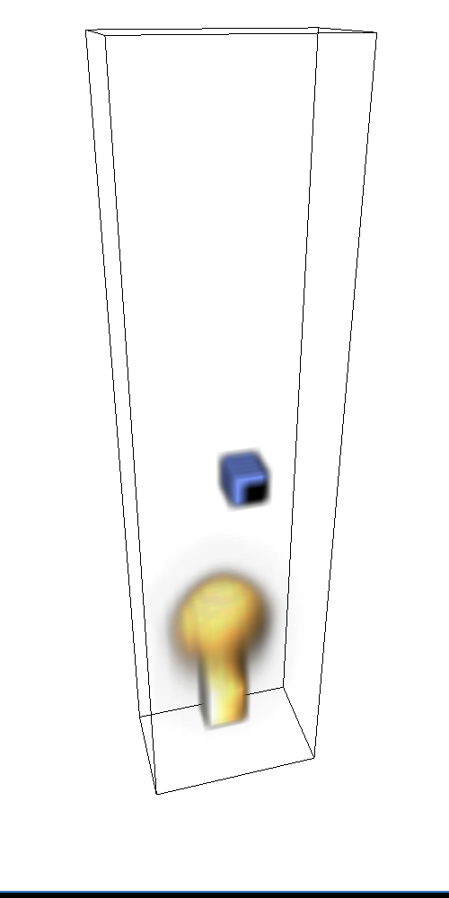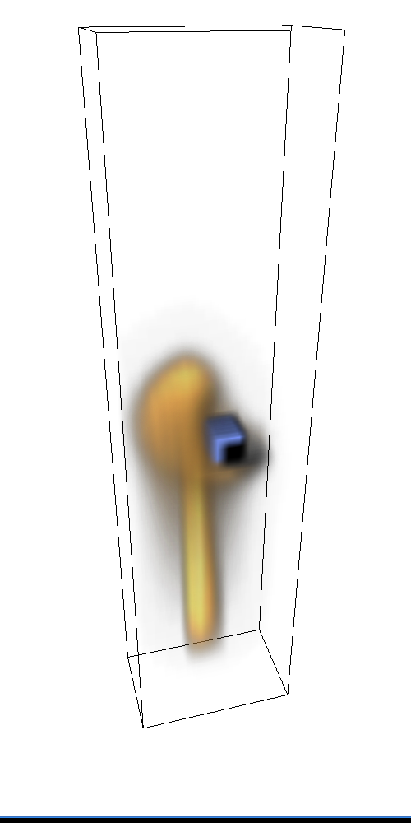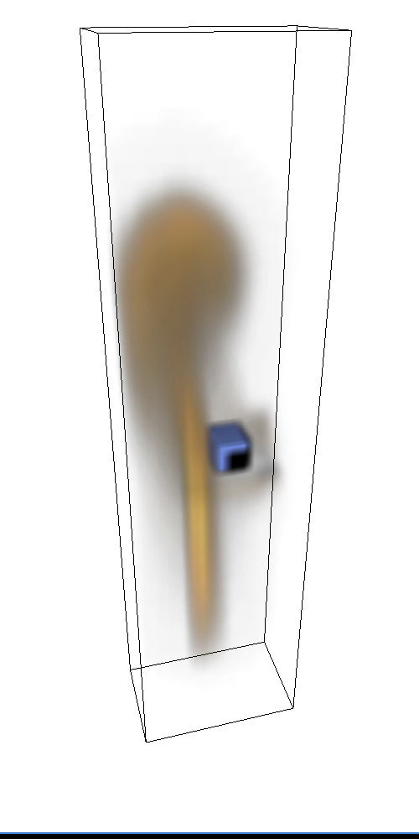
Figure 4. Frames [60, 110, 160] of a smoke simulation, domain size 16x16x64, 5 CG iterations, 40 fps on [DualFAST].
Figure 4 presents a series of pictures from our implementation. It runs about 40 frames per second on [DualFAST], simulating 16 384 voxels. The smoke interacts in a realistic way with the obstacle present in the domain, but suffers from the numerical dissipation and lack of detail pointed out by Fedkiw et al. [].
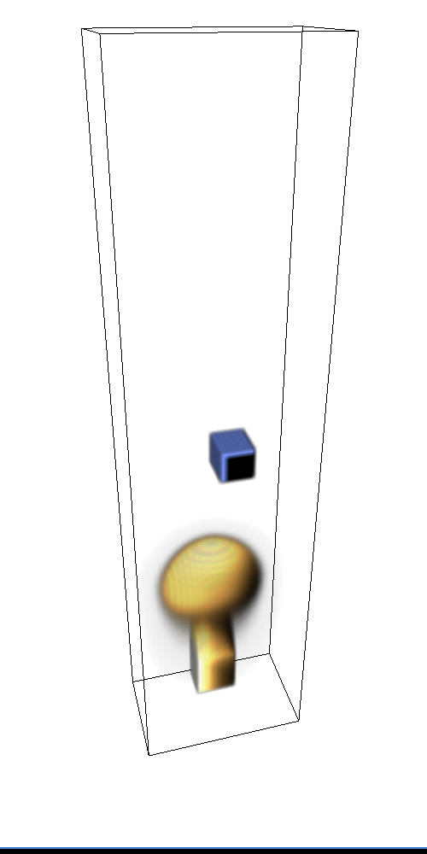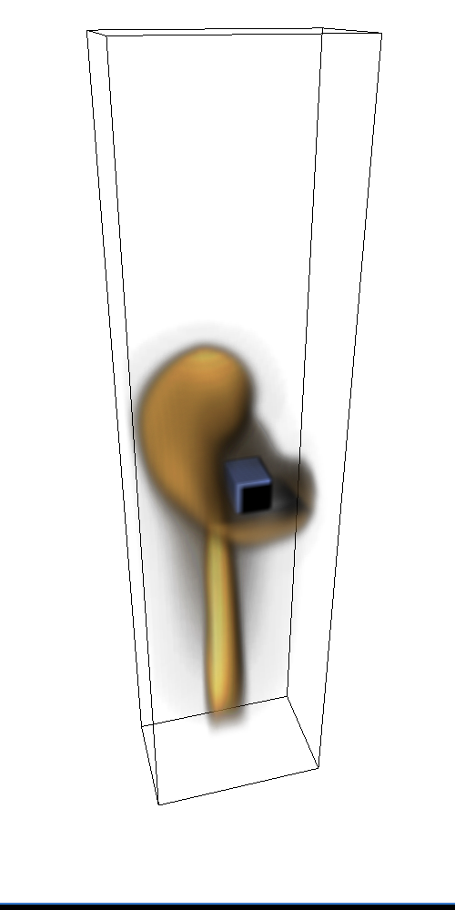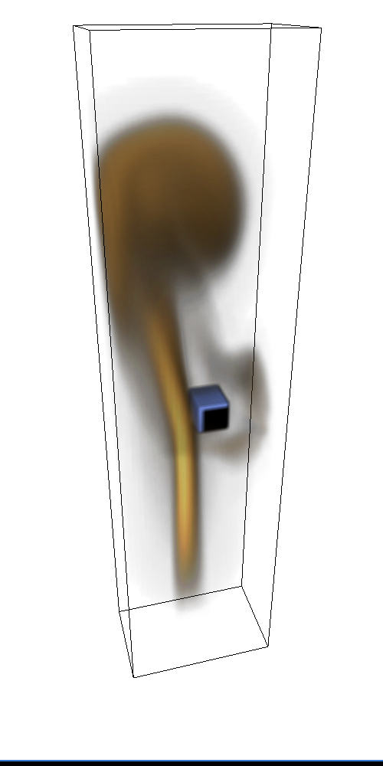
Figure 5. Frames [60, 110, 160] of a smoke simulation, grid sized 32x32x128, 5 CG iterations, fps = 4.1.
Figure 5 presents a simulation with the exact same parameters as Figure 4, but features eight times as many voxels (131 072). The detail is greatly improved, but the result is only 4 frames per second.
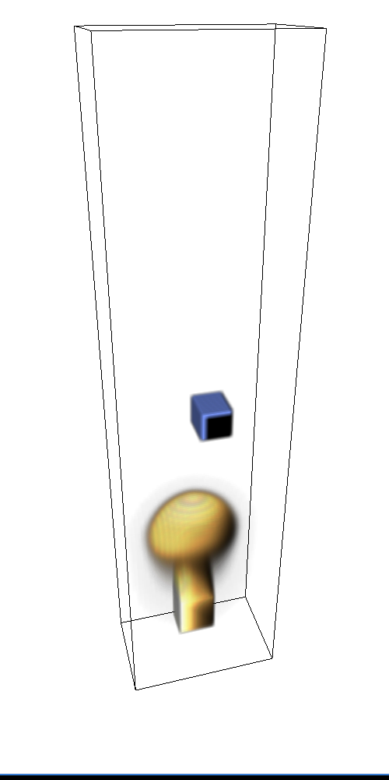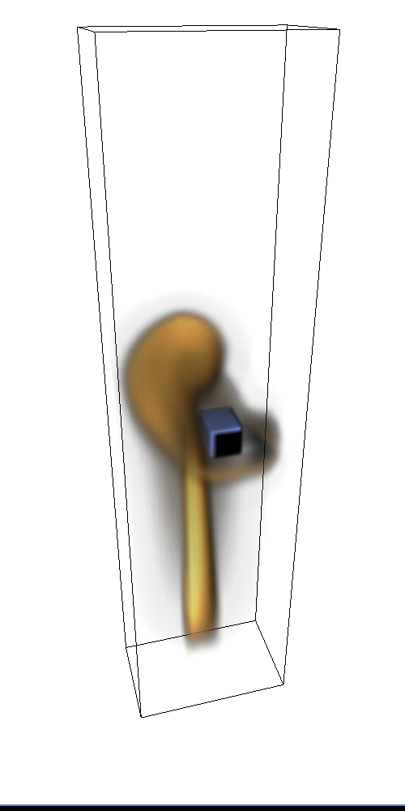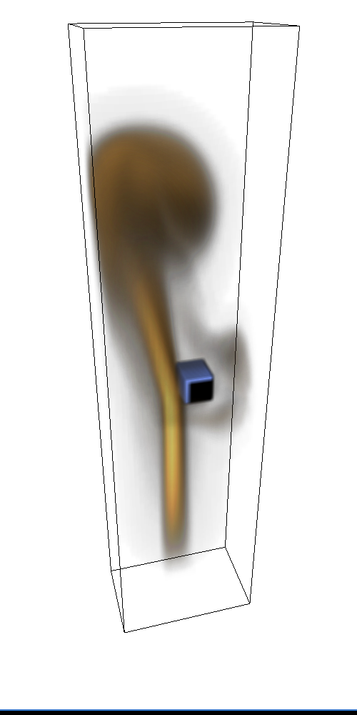

Figure 6. Frame 60, 110 and 160 of a smoke simulation, grid sized 32x32x128, 500 CG iterations, fps = 0.16.

In Figure 6, the number of CG iterations is increased to 500 and illustrates an interesting fact: the number of iterations has little or no effect on the visual simulation.
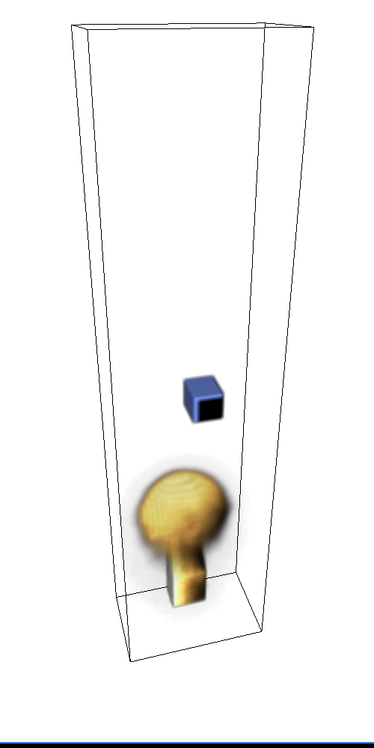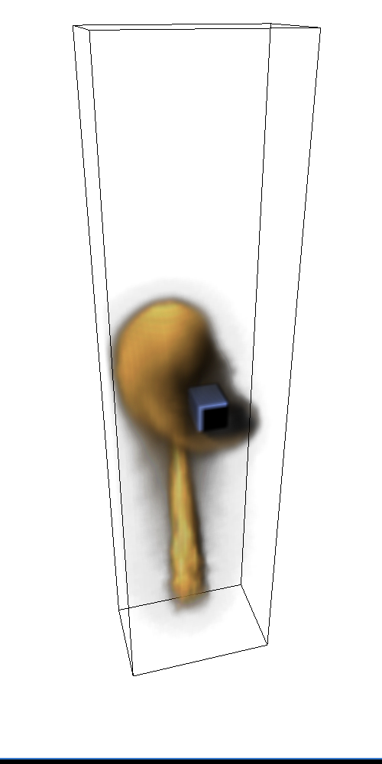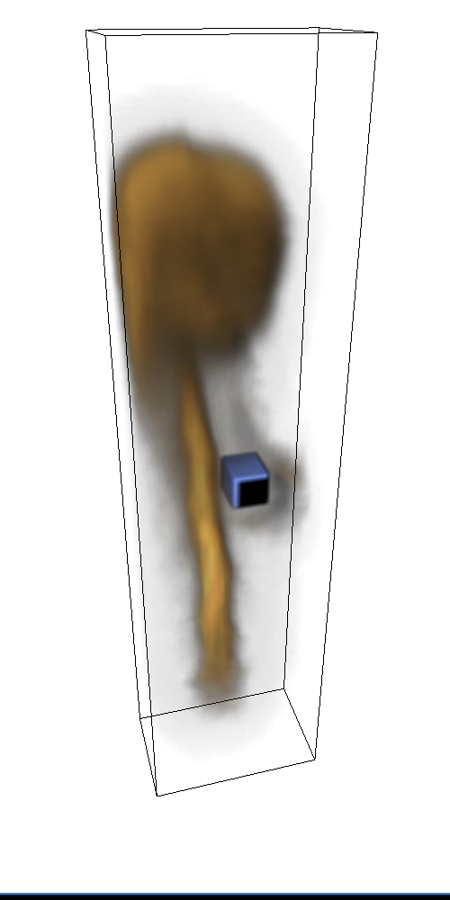
Figure 7. Frame 60, 110 and 160 of a smoke simulation, grid sized 32x32x128, 5 CG iterations, fps = 4.1.

Figure 7 illustrates the effect of introducing small random forces into the domain, and show, in comparison with Figure 5, that the smoke looks less "smooth" and for some situations more realistic.
- Conclusion
Fedkiw et al. [] report a few benchmark results of their hardware rendering implementation, running on a dual PentiumIII-800. It is important to note that Fedkiw does not mention whether their implementation actually utilizes both CPUs or not. They spend about 1 second per frame for 64.000 voxels, or about 0.1 sec per frame for 16.000 voxels. As a comparison, our implementation spends 0.31s per frame for 65536 voxels and 0.08s for 16384 voxels, both results produced on a single CPU PentiumIII-1000. Assuming that Fedkiw et al. only utilizes one of the CPUs, the efficiency of the two implementations is more or less identical. If they utilize both CPUs, our is more efficient, but lacks the same amount of visual detail.
The results showed that it is possible to run an optimized implementation of the algorithm outlined by Fedkiw et al.[] that yields 5 to 40 frames per second on today's modern home computing hardware. Algorithmic optimizations, parameter tuning and efficient programming techniques made the implementation capable of animating smoke, still with a satisfactory level of realism and speed in real-time.
We have involved two types of optimizations: model and code. The former modified the algorithm and sacrificed accuracy for speed, while the latter simply increased the efficiency of the program. Three important modifications were done on the model from []:

- Defining the velocity at voxel centers instead of voxel faces
- Fast matrix-free CG (no preconditioner)
- Leaving out the vorticity confinement

These three decisions unquestionably reduced the visual quality of the smoke, a fact supported a by comparison of the visual results presented by Fedkiw et al.[] with the visual results of this thesis (section 4.3). The modifications also reduced the computational complexity of the algorithm, thus making it possible to calculate significantly more frames per second. It is interesting to notice that the number of CG iterations made little or no difference on the visual simulations; a surprising result when seen in the light of earlier discussions []. This effect should be investigated further.
Considering the implementation, utilization of SMP systems was by no doubt the most important programming technique employed in this thesis. The speedups gained by parallel implementations of the algorithms proved them very suitable for such approaches, but also revealed the memory bus as being a limitation for memory intensive tasks. The pipelined approach presented in 3.2 introduced a technique for dynamic job distribution and pipelining, thus reducing the penalty caused by serial sub-tasks such as rendering. The technique of pipelining is well-known, especially within computer hardware engineering, but this thesis showed its relevance within the field visualization. And as most of today's SMP systems still share a common graphics card, the technique could apply to a wide range of visualization software. Results also showed that certain parts of the algorithm gained significant speedups as a result of Intel's SSE instructions, especially the method of Conjugate Gradients.
Some of the aspects discussed in this thesis are linked to a spesific platform (Intel x86, MS Windows) and special situations (coarse grids), but most of the optimizations and techniques would apply for large-scale CFD simulations. It is important to distinguish between visual simulations and physical simulations. This paper aims for the former, as the latter require a significantly higher degree of accuracy. Still, the fundamental Navier-Stokes equations are the same for both directions, and any evolution within one of them will most likely affect the other.
Whether it is possible or not to run a visual CFD simulation in real-time, depends on the desired visual accuracy and quality. Higher software and algorithmic efficiency will allow for higher accuracy on a on a given hardware platform, but the numerical simulations will always have a potential for improvement.
- Future work
There is a wide range of possible extensions for this research. From a visualization point of view, different rendering hardware could be investigated to possibly increase the speed and quality of rendering. The data bus between CPU and graphics card is a significant bottleneck, and techniques could be applied to reduce this bus traffic. Within the field of parallel programming, systems with more than two CPUs should be researched with respect to scaling. Communication analysis for different cluster and distributed models would also be a natural evolution. Use of higher level parallel programming libraries, such as OpenMP [], is another interesting direction. Finally, as this is simulation model for visual purposes, some of the algorithmic shortcuts employed in our model could be removed to regain some of the visual quality.
References
[] R. Fedkiw, J. Stam, and H. W. Jensen. Visual Simulation of Smoke. In SIGGRAPH 2001 Conference Proceedings, Annual Conference Series , pages 15-22, August 2001
[] J. Stam. Stable Fluids. In SIGGRAPH 99 Conference Proceedings, Annual Conference Series, pages 121–128, August 1999.
[] N. Foster and D. Metaxas. Modeling the Motion of a Hot, Turbulent Gas. In SIGGRAPH 97 Conference Proceedings, Annual Conference Series, pages 181–188, August 1997.
[] Henk A. Van Der Vorst. Lecture Notes on iterative methods. Mathematical Institute, University of Utrecht, Budapestlaan, the Netherlands. June 4, 1994.
[] An Introduction to the Conjugate Gradient Method Without the Agonizing Pain Edition 1.25. Jonathan Richard Shewchuk, August 4., 1994, http://www-2.cs.cmu.edu/~jrs/jrspapers.html
[] Peter Bartello and Stephen J. Thomas. The Cost-Effectiveness of Semi-Lagrangian Advection. Dr. P. Bartello, RPN, 2121, voie de Service nord, Route Transcanadienne, Dorval (Quebec) H9P 1J3.
[] Fred T. Tracy. A Comparison of a Relaxation Solver and a Preconditioned Conjugate Gradient Solver in Parallel Finite Element Groundwater Computations. Engineer Research and Development Center, Major Shared Resource Center. http://www.hpcmo.hpc.mil/Htdocs/UGC/UGC01/paper/fred_tracy_paper.pdf
[] G. Y. Gardner. Visual Simulation of Clouds. Computer Graphics (SIGGRAPH 85 Conference Proceedings), 19(3):297–384, July 1985.
[] C. M. Stein, N L Max. A Particle-Based Model for Water Simulation. (SIGGRAPH 98 Conference, july 19-24)
[] K. Perlin. An Image Synthesizer. Computer Graphics (SIGGRAPH85 Conference Proceedings), 19(3):287–296, July 1985.
[] OpenMP, http://www.openmp.org

