Realtime Simulation of Smoke

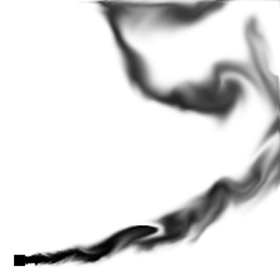

2002
Torbjørn Vik

Abstract
This paper describes an approach for optimizing smoke simulations. The method is based on simple linear interpolation to insert intermediate frames between frames in the animated simulation. The actual smoke simulation exploits physics unique to smoke in order to design a numerical method that is both fast and efficient on the relatively coarse grids traditionally used in computer graphics applications (as compared to the much finer grids used in the computational fluid dynamics literature). The model uses inviscid Euler equations, since they are usually more appropriate for gas modeling and less computationally intensive than the viscous Navier-Stokes equations used by others. The model also correctly handles the interaction of smoke with moving objects.

Keywords: Smoke, computational fluid dynamics, Navier-Stokes equations, Euler equations, Semi-Lagrangian methods, stable fluids, participating media
Preface
This project was defined by Torbjørn Vik in association with Torbjørn Hallgren as follows:

This project aims for a realtime implementation of the approach for simulating smoke described in [].

[...]

Significate time will be spent investigating different public software libraries offering functionality for solving the Poisson-equation with e.g. the method of Conjugate Gradients. This research will, during the engineering phase, eventually result in development of a working prototype. The implementation will rougly be divided into two parts, data generation and data visualization.

One of the essential goals is to implement a simulation running in realtime, producing satisfactory visual results. In order to have a basis of comparison, this project defines realtime to approx 1 fps.

A realistic goal for this project is a working prototype producing correct visual results, using public libraries for calculations and possibly some optimizing tricks for the visualization part.

The search for an appropriate public library to aid with the simulation failed terribly. A number of candidates were evaluated, but none contained the required functionality in combination with satisfactory ease of use. The result was a two dimensional prototype implementing the entire model on it's own, without any support from external software packages. Recent benchmarks has shown that this probably was a fortunate solution, as the CG solver implemented easily outruns e.g. PETSC's CG solver. Local knowledge of the set of equations opens for special programming shortcuts a general scientific library such as PETSC cannot possibly exploit (see section 4.1).

A special algorithmic optimization were also implemented and tested, producing animations with upto 3 times more frames per second. This algorithm is presented in section 3.

Torbjørn Vik, 22. November 2002
Index
Abstract 2
Preface 3
Index 4
1. Introduction 5
1.1. Previous work 5
1.2. Approximation 6
2. The Model 7
2.1. Basic equations of fluid flow 7
2.2. Semi-Lagrangian Advection 9
2.2.1. Introduction 9
2.2.2. Trajectory Integration 10
2.3. The Poisson Equation 13
2.4. The method of Conjugate Gradients 19
2.4.1. Introduction 19
2.4.2. The quadratic form 20
2.4.3. The Method of Steepest Descent 23
2.4.4. The method of Conjugate Gradients 27
3. n-frame interpolation 29
3.1. Algorithm 29
3.2. Limitations 31
4. Implementation 33
4.1. Simulation 33
4.2. Rendering 36
5. Results 37
6. Conclusion 41
6.1. Visual results 41
6.2. Optimization results 41
6.2.1. Future work 43
Appendix A Discretization 44
References 45

- Introduction
The modeling of natural phenomena such as smoke remains a challenging problem in computer graphics. This is not surprising since the motion of gases/fluids such as smoke is highly complex and turbulent. Also, building animation tools for such fluid-like motions is an important area with many obvious applications in the industry including special effects and interactive games. Physical models, unlike keyframe or procedural based techniques, permit an animator to almost effortlessly create interesting, swirling fluid-like behaviors. Also, the interaction of flows with objects and virtual forces is handled elegantly. Ideally, a good smoke model should both be easy to use and produce highly realistic results.

Obviously the modeling of smoke and gases is of importance to other engineering fields as well. More generally, the field of computational fluid dynamics (CFD) is devoted to the simulation of gases and other fluids such as water. Only recently have researchers in computer graphics started to excavate the abundant CFD literature for algorithms that can be adopted and modified for computer graphics applications. Unfortunately, many computer graphic smoke models are either too slow or suffer from too much numerical dissipation. [] adapts techniques from the CFD literature specific to the animation of gases such as smoke, and the model used are stable, rapid and doesn’t suffer from excessive numerical dissipation. This makes it possible to produce animations of complex rolling smoke even on relatively coarse grids (as compared to the ones used in CFD).

Section 2.1 covers the physical model of the smoke simulation, based heavily on [], but ignoring the vorticity confinement. Section 2.2, 2.3 and 2.4 presents the different underlying mathematical algorithms and methods used in the implementation. Section 3 describes the actual contribution of this paper, with results in section 5 and conclusion/discussion in section 6.
  - Previous work
The modeling of smoke and other gaseous phenomena has received a lot of attention from the computer graphics community over the last two decades. Early models focused on a particular phenomenon and animated the smoke’s density directly without modeling its velocity [], [], [] and []. Additional detail was added using solid textures whose parameters were animated over time. Subsequently, random velocity fields based on a Kolmogoroff spectrum were used to model the complex motion characteristic of smoke []. A common trait shared by all of these early models is that they lack any dynamical feedback. Creating a convincing dynamic smoke simulation is a time consuming task if left
to the animator.

A more natural way to model the motion of smoke is to simulate the equations of fluid dynamics directly. Kajiya and Von Herzen were the first in computer graphics to do this []. Unfortunately, the computer power available at the time (1984) only allowed them to produce results on very coarse grids. Except for some models specific to two dimensions [], [], no progress was made in this direction until the work of Foster and Metaxas [], []. Their simulations used relatively coarse grids but produced nice swirling smoke motions in three dimensions. Because their model used an explicit integration scheme, the simulations were only stable if the time step was chosen small enough. This made their simulations relatively slow, especially when the fluid velocity were large anywhere in the domain of interest. To alleviate this problem Stam introduced a model which was unconditionally stable and consequently could be run at any speed []. This was achieved using a combination of a semi-Lagrangian advection schemes and implicit solvers. Because a first order integration scheme was used, the simulations suffered from too much numerical dissipation. Although the overall motion looks fluid-like, small scale vortices typical of smoke vanish too rapidly.

Yngve et al. has proposed solving the compressible version of the equations of fluid flow to model explosions []. While the compressible equations are useful for modeling shock waves and other compressible phenomena, they introduce a very strict time step restriction associated with the acoustic waves. Most CFD practitioners avoid this strict condition by using the incompressible equations whenever possible.
  - Approximation
This paper describes computer simulated animation of smoke for the purpose of realtime visualization, e.g. as feedback in interactive applications of different kind. Applications implementing this paper will typically aim for credible visual results, not necessarily physically correct simulations. Additional algorithmic shortcuts increasing the number of frames per second at the cost of accuracy may therefore be perfectly accceptable. This paper presents a simple approximation method that theoretically increases the framerate by about a factor n at the cost of visual accuracy.

- The Model
  - Basic equations of fluid flow
This model assumes that gases can be modeled as inviscid, incompressible, constant density fluids. The effects of viscosity are negligible in gases especially on coarse grids where numerical dissipation dominates physical viscosity and molecular diffusion. When the smoke’s velocity is well below the speed of sound the compressibility effects are negligible as well, and the assumption of incompressibility greatly simplifies the numerical methods. Consequently, the equations that model the smoke’s velocity, denoted by $u=\left(u,v,w\right)$ are given by the incompressible Euler equations.

Eq $∇⋅u=0$

Eq $\frac{∂u}{∂t}=−(u⋅∇)u−∇p+f$

These two equations state that the velocity should conserve both mass (Eq ) and momentum (Eq ). The quantity p is the pressure of the gas and f accounts for external forces. Also the fluid's density is arbitrarily set to one. As in [], [] and [] the equations are solved in two steps. First, an intermediate velocity field u* are computed by solving Eq over a time step Δt without the pressure term

Eq $\frac{u∗−u}{Δt}=−(u⋅∇)u+f$

After this step, the field u* is forced to be incompressible using a projection method []. This is equivalent to computing the pressure from the following Poisson equation

Eq $∇^{2}p=\frac{1}{Δt}∇⋅u∗$

with pure Neumann boundary condition, i.e. $\frac{∂p}{∂n}=0$, at a boundary point with normal n. The intermediate velocity field is then made incompressible by subtracting the gradient of the pressure from it

Eq $u=u∗−Δt∇p$

Equations for the evolution of both the temperature T and the smoke’s density ρ are also required. These two scalar quantities are simply moved (advected) along the smoke’s velocity

Eq $\frac{∂T}{∂t}=−(u⋅∇)T$
Eq $\frac{∂ρ}{∂t}=−(u⋅∇)ρ$

Both the density and the temperature affect the fluid’s velocity. Heavy smoke tends to fall downwards due to gravity while hot gases tend to rise due to buoyancy. A simple model is implemented to account for these effects by defining external forces that are directly proportional to the density and the temperature

Eq $f_{\text{buoy}}=−\text{αρ}z+β(T−T_{\text{amb}})y$

where $y=\left(0,1\right)$ points in the upward vertical direction, $T_{\text{amb}}$ is the ambient temperature of the air and α and β are two positive constants with appropriate units such that Eq is physically meaningful. Note that when $ρ=0$and $T=T_{\text{amb}}$, this force is zero. Eq , Eq and Eq all contain the advection operator $−\left(u⋅∇\right)$. As in [], this term is solved using a semi-Lagrangian method [], and the Poisson equation (Eq ) for the pressure is solved using an iterative solver. Section 4.1 show how these solvers can also handle bodies immersed in the fluid.
  - Semi-Lagrangian Advection
    - Introduction
Semi-Lagrangian (S-L for short) methods, also called quasi-Lagrangian, have been around since the early 1960’s and T.N. Krishnamurti was probably the first to use S-L method. The S-L scheme becomes really popular following Andre Robert’s work in the early 80’s when he combined the use of S-L with semi-implicit method (SLSI) which allows for large time step size because both schemes are unconditionally stable. The SL scheme deals with the advection part, and the SI scheme deals with faster wave propagation.

The major principal reason for using SL methods in favor of more traditional Eularian approaches is to overcome the CFL constraint which is based on stability, not accuracy considerations. That is, from on accuracy point of view, we could live with a much larger Δt than which is required by the linear stability condition because time truncation error is often smaller than spatical truncation error. Another minor reason is the fact that SL methods solve the equations in Lagrangian form, i.e., $\frac{\text{du}}{\text{dt}}=0$ rather than the advection form, i.e., $\frac{∂u}{∂t}+\vec{V}⋅∇u=0$, and there is no instability due to aliasing.

In the case of pure advection, stability depends upon the transport velocity. Since advection term does not appear in SL methods, there is no time step constraint for SL schemes. Of course other modes can be present in the problem. For example, internal gravity waves, which can impose more severe limitation on Δt unless they are treated implicitly. Hence the SLSI methods (SI for Semi Implicit).

Semi-Lagrangian methods tries to combine two methods in order to gather the best of both world. In the Eulerian approach, one use a fixed set of points and unless grid refinement methods are used, there is always a fixed number of points in the system. Lagrangian is the other extreme. Here, the mesh actually follows the fluid and can become distorted, necessitating a remapping operating from time to time. The semi-Lagrangian seeks to combine these two methods by moving data relative to a fixed (in space) grid. It is also called the method of Characteristics.

The advection equation is

Eq $\frac{dφ}{\text{dt}}=\frac{∂φ}{∂t}+\left(u⋅∇\right)φ=0, φ=φ\left(x\left(t_{0}\right),t\right)$

where the velocity vector along trajectories is

Eq $\frac{\text{dx}}{\text{dt}}=u\left(x,t\right)$

To obtain φ at a grid point x, a two-time level-level semi-Lagrangian scheme integrates along a fluid particle trajectory originating at the departure point $\left(x\text{*,}t_{n−1}\right)$ and terminating at the arrival point $\left(x,t_{n}\right)$

Eq $\frac{φ\left(x,t_{n}\right)−φ\left(x\text{*,}t_{n−1}\right)}{Δt}=0$

where $x∗x−\vec{α}$. According to Eq the value of φ at the arrival point is simply equal to the value at the departure point. Thus, numerical interpolation is often used to compute $φ(x\text{*,}t_{n−1})$, since a departure point generally lies between grid points. In essence, the method depends on an accurate computation of the displacement $\vec{α}$. For a three-time-level scheme, [] proposed an $O\left({Δt}^{2}\right)$ accurate approximation of u

Eq ${\vec{α}}^{\left[k+1\right]}=Δ\text{tu}\left(x−{\vec{α}}^{\left[k\right]},t_{n}−Δt\right)$

where the midpoint velocity $u\left(x−\vec{α},t_{n}−Δt\right)$ is obtained by interpolation. The approximation Eq is an implicit midpoint integration method combined with a fixed point corrector iteration, and several low cost alternatives are described below. Given an initial guess ${\vec{α}}^{\left[0\right]}=Δt\left(x,t_{n−1}\right)$, [] showed that a necessary condition for convergence is that the velocity gradient satisfy

Eq $Δt\left|\frac{∂u}{∂x}\right|<1$

and that two iterations are normally sufficient. [] also prove that the condition Eq is sufficient to guarantee that trajectories do not intersect during a timestep $Δt$. The two basic steps in any semi-Lagrangian method are therefore trajectory integration and upstream interpolation.
    - Trajectory Integration
The potentially high cost of the trajectory integration method Eq in 3D has been noted by several authors. [] discussed the relationship between the accuracy of the departure point computation and the overall accuracy of a semi- Lagrangian advection scheme and suggests several low-cost alternatives to the iteration Eq . A discussion concerning the tradeoffs between computational overhead and achievable accuracy for semi-Lagrangian schemes, in particular related to the trajectory computation Eq , can be found in a series of articles by [], [] and [].

[] observed that the trajectory integration method Eq is in fact a one-step midpoint Runge-Kutta method for the backward in time numerical integration

$$x∗x+\int_{t_{n}}^{t_{m!}}{u\left(x,t\right)\text{dt}}$$

of the ordinary differential equation (ODE) represented by the trajectory Eq . In fact, there exist two one-step Runge-Kutta methods having second order accuracy, the trapezoidal and midpoint methods. The trapezoidal method is

Eq $x∗x−\frac{Δt}{2}\left[u\left(x,t_{n}\right)+u\left(x−Δ\text{tu}\left(x,t_{n}\right),t_{n}−Δt\right)\right]$

whereas the midpoint method is

Eq $x∗x−Δ\text{tu}\left(x−\frac{Δt}{2}u\left(x,t_{n}\right),t_{n}−\frac{Δt}{2}\right)$

The objective in primitive variable formulations of the governing equations is to compute the velocity $u(x,t_{n})$ from information at previous time levels. Since the velocity is not available at $t_{n}$, the above integration schemes are implicit numerical methods.

The iteration Eq proposed by [] is therefore a nonlinear implicit corrector iteration based on the midpoint method. An initial estimate of the upstream position given by ${\vec{α}}^{\left[0\right]}=Δ\text{tu}\left(x,t_{n}−Δt\right)$ is in fact a first order prediction of the position

$$x∗x−Δ\text{tu}\left(x,t_{n}−Δt\right)$$

or zero order estimate of the velocity $u\left(x,t_{n}\right)=u\left(x,t_{n}−Δt\right)$. Since the predictor is less accurate than the corrector, several iterations are required in order to achieve $O\left({Δt}^{2}\right)$ accuracy (see []). In the context of a two-time-level scheme, [] also employed the midpoint method and thus the midpoint velocity is required. They combined a linear extrapolation of the velocity

$$u\left(x,t_{n}−\frac{Δt}{2}\right)=\frac{3}{2}u\left(x,t_{n}−Δt\right)−\frac{1}{2}u\left(x,t_{n}−2Δt\right)$$

with the estimate ${\vec{α}}^{\left[0\right]}=Δ\text{tu}\left(x,t_{n}−Δt\right)$ and then iterated

$${\vec{α}}^{\left[k+1\right]}=Δ\text{tu}\left(x−\frac{{\vec{α}}^{\left[k\right]}}{2},t_{n}−\frac{Δt}{2}\right)$$

Here again, since the predictor is less accurate than the corrector, several iterations are required (see [], p. 2114). [] note the strong connection with numerical ODE solvers and demonstrate that one iteration of a second order corrector is sufficient for $O\left({Δt}^{2}\right)$ accuracy when combined with a second order predictor. They also observe that the condition Eq is a necessary condition for convergence of a fixed-point predictor-corrector type ODE solver. [] combined a quadratic extrapolation based on Adams predictor-corrector methods with a one-step trapezoidal Runge-Kutta method. In this case, an $O\left({Δt}^{2}\right)$ accurate velocity is computed

$$u\left(x,t_{n}\right)=\frac{\text{23}}{\text{12}}u\left(x,t_{n−1}\right)−\frac{\text{16}}{\text{12}}u\left(x,t_{n−2}\right)+\frac{5}{\text{12}}u\left(x,t_{n−3}\right)$$

and then iteration of the trapezoidal method

$$x∗x−\frac{Δt}{2}\left[u\left(x,t_{n}\right)+u\left(x−Δ\text{tu}\left(x,t_{n}\right),t_{n}−Δt\right)\right]$$

is employed as a corrector. The number of corrector iterations is an important consideration since the operation count increases substantially with each iteration when the velocity is interpolated at upstream points.

  - The Poisson Equation
The general Poission Equation with two variables is defined as

Eq $∇^{2}u=g(x,y)$

Suppose that a function $u=u(x,y)$ of two variables is the solution to a certain physical problem. This function is unknown but has some properties that, theoretically, determine it uniquely. It is assumed that on a given region R in the xy-plane,

Eq $\begin{aligned}\left\{∇^{2}u+\text{fu}=g | \right.\end{aligned}$

Here $f=f(x,y)$ and $g=g(x,y)$ are given continous functions defined in R. The boundary values could be given by a third function.

$$u(x,y)=q(x,y)$$

on the perimeter of R. When f is a constant, this partial differential equation is called the Helmholtz equation, and arises in looking for oscillatory solutions to the wave equations.

The goal is to find an approximate solution of the problem by the finite-difference method. The first step is to select approximate formulas for the derivatives in the problem.

Eq $f\text{''}(x)≈\frac{1}{h^{2}}\left[f(x+h)−2f(x)+f(x−h)\right]$

Used on a function of two variables, it obtains the five-point formula approximation to Laplace's equation:

Eq $∇^{2}u≈\frac{1}{h^{2}}\left[u(x+h,y)+u(x−h,y)+u(x,y+h)+u(x,y−h)−4u(x,y)\right]$

This formula involves the five points displayed in Figure 1.

The local error inherent in the five-point formula is

Eq $−\frac{h^{2}}{\text{12}}\left[\frac{∂^{4}u}{∂x^{4}}(ε,y)+\frac{∂^{4}u}{∂y^{4}}(x,η)\right]$

and, for this reason, Eq is said to provide an approximation of order $O(h^{2})$. In other words, if grids are used with smaller and smaller spacing, $h→0$, then the error committed in replacing $∇^{2}u$ by it's finite-difference approximation goes to zero as rapidly as does $h^{2}$. Eq is called the five-point formula because it involves values of u at (x, y) and at the four nearest grid points.

Figure 1. Laplace's equation: Five-point stencil.

It should be emphasizxed that when the differential equation in Eq is replaced by the finite-difference analog, the problem is altered. Even if the analogous finite-difference problem is solved with complete precision, the solution is that of a problem that only simulates the original one. This simulation of one problem by another becomes better and better as h is made to decrease to zero, but the computing cost will inevitably increase.

Other representations of the derivatives can be used. For example, the nine-point formula is

Eq $∇^{2}u≈\frac{1}{6h^{2}}\begin{aligned}\left[4u(x+h,y)+4u(x−h,y)+4u(x,y+h)+4u(x,y−h) | \right]\left[+u(x+h,y+h)+u(x−h,y+h)+u(x+h,y−h) | \right] \\ \end{aligned}$

This formula is of order $O(h^{2})$, and could in the case of g being an harmonic function, offer extremely accurate approximations. For more general problems, the nine-point formula has the same order error term as the five-point formula and would not be an improvement over it.

Returning to the Eq , the region R is described by mesh points

Eq $\begin{aligned}x_{i}=\text{ih} \\ y_{j}=\text{jh} \\ (i,j≥0)\end{aligned}$

At this time, it is convenient to introduce an abbreviated notation:

Eq $\begin{aligned}u_{\text{ij}}=u(x_{i},y_{j}) \\ f_{\text{ij}}=f(x_{i},y_{j}) \\ g_{\text{ij}}=g(x_{i},y_{j})\end{aligned}$

With it the five-point formula takes on a simple form at the point $(x_{i},y_{j})$:

Eq $(∇^{2}u)_{\text{ij}}≈\frac{1}{h^{2}}(u_{i+1,j}+u_{i−1,j}+u_{i,j+1}+u_{i,j−1}−4u_{\text{ij}})$

If this approximation is made in the differential Eq , the result is

Eq $−u_{i+1,j}−u_{i−1,j}−u_{i,j+1}−u_{i,j−1}+\left(4−h^{2}f_{\text{ij}}\right)u_{\text{ij}}=−h^{2}g_{\text{ij}}$

The coefficients of this equation can be illustrated by a five-point star in which each point corresponds to the coefficient of u in the grid (see Figure 3).

1

2

3

4

5
1 2 3 4 5
Figure 2. Uniform grid spacing.

To be specific, the region R is a unit square and the grid has spacing h (see Figure 2). A single linear equation of the form Eq is constructed for each of the nine interior grid points. These nine quations are as follows:

$$\begin{aligned}\left\{−u_{\text{12}}−u_{\text{32}}−u_{\text{23}}−u_{\text{21}}+(4−h^{2}f_{\text{22}})u_{\text{22}}=−h^{2}g_{\text{22}} | \right.\left\{−u_{\text{22}}−u_{\text{42}}−u_{\text{33}}−u_{\text{31}}+(4−h^{2}f_{\text{32}})u_{\text{32}}=−h^{2}g_{\text{32}} | \right.\left\{−u_{\text{52}}−u_{\text{32}}−u_{\text{43}}−u_{\text{41}}+(4−h^{2}f_{\text{42}})u_{\text{42}}=−h^{2}g_{\text{42}} | \right.\left\{−u_{\text{13}}−u_{\text{33}}−u_{\text{24}}−u_{\text{22}}+(4−h^{2}f_{\text{23}})u_{\text{23}}=−h^{2}g_{\text{23}} | \right.\left\{−u_{\text{43}}−u_{\text{23}}−u_{\text{34}}−u_{\text{32}}+(4−h^{2}f_{\text{33}})u_{\text{33}}=−h^{2}g_{\text{33}} | \right.\left\{−u_{\text{53}}−u_{\text{33}}−u_{\text{44}}−u_{\text{42}}+(4−h^{2}f_{\text{43}})u_{\text{43}}=−h^{2}g_{\text{43}} | \right.\left\{−u_{\text{34}}−u_{\text{14}}−u_{\text{25}}−u_{\text{23}}+(4−h^{2}f_{\text{24}})u_{\text{24}}=−h^{2}g_{\text{24}} | \right.\left\{−u_{\text{44}}−u_{\text{24}}−u_{\text{35}}−u_{\text{33}}+(4−h^{2}f_{\text{34}})u_{\text{34}}=−h^{2}g_{\text{34}} | \right.\end{aligned}$$

This system of equations could be solved through Gaussian elimination, but some examination uncovers a total of 45 coefficients. Since u is known at the boundary points, these 12 terms is moved to the right-hand side, leaving only 33 nonzero entires out of 81 in the 9x9 system. The standard Gaussian elimination causes a great deal of fill-in in the forward eliminiation phase - that is, zero entries being replaced by nonzero values. A method that retains the sparse structure of this system would be a better choice. Writing this system in matrix notation, it becomes clear how sparse it really is:

Eq $\text{Au}=b$

-1
-1
-1
-1
Figure 3. Helmholtz equations: Five-point star.

Then, ordering the unknowns from left to right and bottom to top:

Eq $u=\left[u_{\text{22}},u_{\text{32}},u_{\text{42}},u_{\text{23}},u_{\text{33}},u_{\text{43}},u_{\text{24}},u_{\text{34}},u_{\text{44}}\right]$

This is called natural ordering. Now the coefficient matrix is

$$\left[\begin{matrix}4−h^{2}f_{\text{22}} & −1 & 0 & −1 & 0 & 0 & 0 & 0 & 0 \\ −1 & 4−h^{2}f_{\text{32}} & −1 & 0 & −1 & 0 & 0 & 0 & 0 \\ 0 & −1 & 4−h^{2}f_{\text{42}} & 0 & 0 & −1 & 0 & 0 & 0 \\ −1 & 0 & 0 & 4−h^{2}f_{\text{23}} & −1 & 0 & −1 & 0 & 0 \\ 0 & −1 & 0 & −1 & 4−h^{2}f_{\text{33}} & −1 & 0 & −1 & 0 \\ 0 & 0 & −1 & 0 & −1 & 4−h^{2}f_{\text{43}} & 0 & 0 & −1 \\ 0 & 0 & 0 & −1 & 0 & 0 & 4−h^{2}f_{\text{24}} & −1 & 0 \\ 0 & 0 & 0 & 0 & −1 & 0 & −1 & 4−h^{2}f_{\text{34}} & −1 \\ 0 & 0 & 0 & 0 & 0 & −1 & 0 & −1 & 4−h^{2}f_{\text{44}}\end{matrix}\right]$$
and the right-hand side is

$$b=\begin{aligned}\left[−h^{2}g_{\text{22}}+u_{\text{12}}+u_{\text{21}} | \right]\left[−h^{2}g_{\text{32}}+u_{\text{31}} | \right]\left[−h^{2}g_{\text{42}}+u_{\text{52}}+u_{\text{41}} | \right]\left[−h^{2}g_{\text{23}}+u_{\text{13}} | \right]\left[−h^{2}g_{\text{33}} | \right]\left[−h^{2}g_{\text{43}}+u_{\text{53}} | \right]\left[−h^{2}g_{\text{24}}+u_{\text{14}}+u_{\text{25}} | \right]\left[−h^{2}g_{\text{34}}+u_{\text{35}} | \right] \\ \end{aligned}$$

  - The method of Conjugate Gradients
    - Introduction
The method of Conjugate Gradients (CG) is the most prominent iterative method for solving sparse systems of linear equations, and is effective for systems of the form

Eq $\text{Ax}=b$

where x is an unknown vector, b is a known vector, and A is a known, square, symmetric and positive-definite (or positive-indefinite) matrix.

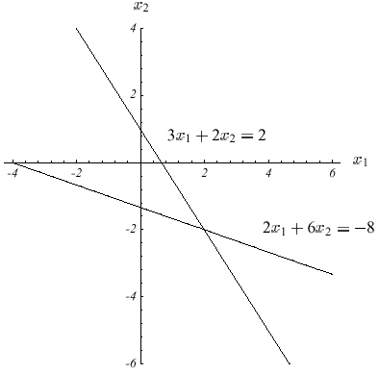
Figure 4. Sample two dimensional linear system. The solution lies at the intersection of the lines.

A matrix A is positive-definite if, for every nonzero vector x,

Eq $x^{T}\text{Ax}>0$

These systems arise in many important settings, such as finite difference and finite element methods for solving partial differential equations, structural analysis and circuit analysis.

Iterative methods like CG are suited for use with sparse matrices. If A is dense, the best course of action is probably to factor A and solve the equation by backsubstitution. The time spent factoring a dense A is roughly equivalent to the time spent solving the system iteratively, but factoring may be impossible due to limited memory, and will be time-consuming as well; even the backsolving step may be slower than iterative solution. On the other hand, most iterative methods are memory-efficient and run quickly with sparse matrices.
    - The quadratic form
A quadratic form is a scalar, quadratic function of a vector with the form

Eq $f(x)=\frac{1}{2}x^{T}\text{Ax}−b^{T}x+c$

where A is a matrix, x and b are vectors, and c is a scalar constant. The simple sample problem

Eq $A=\begin{aligned}\left[3 2 | \right] \\ \end{aligned}$

demonstrates that when A is a symmetric and positive-definite matrix, f(x) is minimized the solution to Ax = b. The solution to f(x) lies at the intersection of the two lines in Figure 4.

The system Ax = b x = b is illustrated in Figure 4. In general, the solution x lies at the intersection point of n hyperplanes, each having dimension n - 1. For this problem, the solution is $x={\left[2,−2\right]}^{T}$. The corresponding quadratic form f(x) appears in Figure 5. A contour plot of f(x) is illustrated in Figure 7.
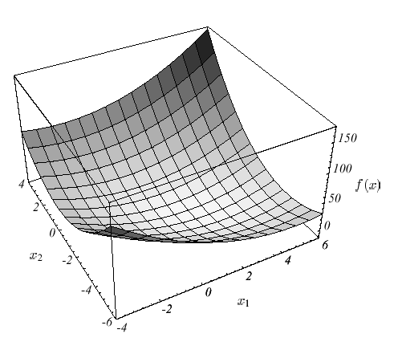
Figure 5. Graph of quadratic form f(x). The minimum point of this surface is the solution to Ax = b

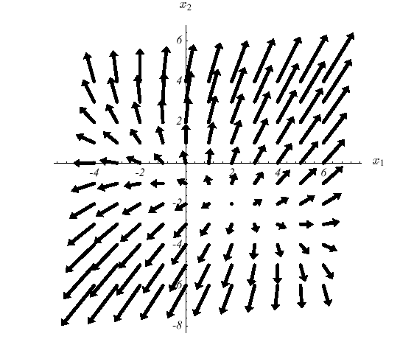
Figure 6. Gradient f(x) of the quadratic form. For every x, the gradient points in the steepest increase of f(x), and is orthogonal to the contour lines.

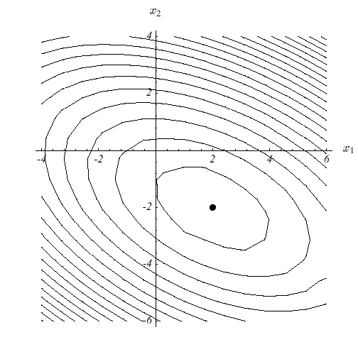
Figure 7. Contours of the quadratic form. Each ellipsoidal curve has constant f(x).
Because A is positive-definite, the surface defined by f(x) is shaped like a paraboloid bowl. The gradient of a quadratic form is defined to be

Eq $f'(x)=\begin{aligned}\left[\frac{∂}{∂x_{1}}f(x) | \right]\left[\frac{∂}{∂x_{2}}f(x) | \right]\left[⋮ | \right] \\ \end{aligned}$

4
The gradient is a vector field that, for a given point x, points in the direction of greatest increase of f(x). Figure 6 illustrates the gradient vectors for Eq with the constants given in Eq . At the bottom of the paraboloid bowl, the gradient is zero. One can minimize f(x) by setting f'(x) equal to zero.

With a little bit of tedious math, Eq can be applied to Eq to derive

Eq $f'(x)=\frac{1}{2}A^{T}x+\frac{1}{2}\text{Ax}−b$

If A is symmetric, this equation reduces to

Eq $f'(x)=\text{Ax}−b$

Setting the gradient to zero gives Eq , the linear system to be solved. Therefore, the solution to Ax = b is a critical point of f(x). If A is positive-definite as well as symmetric, then this solution is a minimum of f(x), so Ax = b can be solved by finding an x that minimizes f(x).

The method of Conjugate Gradient is an iterative solver to find x. It is based on the methods of Steepest Descent and Conjugate Directions, where the former will be presented in the following sections to demonstrate the principles behind Conjugate Gradients. Conjugate Directions is a variant of Steepest Descent where a set of orthogonal search directions are constructed using Gram-Schmidt Conjugation, and the solver uses these directions to avoid repeated stepping along the same direction. Conjugate Gradients is simply the method of Conjugate Directions where the search directions are constructed by conjugation of the residuals (see [] for complete description and proof for all three methods). The complete algorithm for Conjugate Gradients is with pseudocode presented in section 2.4.4.
    - The Method of Steepest Descent
In the Method of Steepest Descent, an arbitrary point $x_{(0)}$is selected and one slides down to the bottom of the paraboloid. A series of steps x(1), x(2),... results in an solution is close enough to the correct solution x.

For each step, the direction in which f decreases most quickly is chosen, which is the direction opposite $f'(x_{(i)})$. According to Eq , this direction is $−f'(x_{(i)})=b−{\text{Ax}}_{(i)}$. The error $e_{(i)}=x_{(i)}−x$ is a vector that indicates how far $x_{(i)}$ is from the solution. The residual $r_{(i)}=b−{\text{Ax}}_{(i)}$ indicates how far $x_{(i)}$ is from the correct value of b. It is easy to see that $r_{(i)}=−{\text{Ae}}_{(i)}$, and the residual is the error transformed by A into the same space as b. More importantly, $r_{(i)}=−f'(x_{(i)})$, in other words the residual is also the direction of steepest descent.

Suppose an example were the traversing starts at $x(0)={\left[−2,−2\right]}^{T}$. The first step, along the direction of steepest descent, will fall somewhere on the solid line in Figure 8(a). In other words, a point

Eq $x_{(1)}=x_{(0)}+{αr}_{(0)}$

A line search is a procedure that chooses α to minimize f along a line. Figure 8(b) illustrates this task: the point must be chosen on the intersection of the vertical plane and the paraboloid. Figure 8(c) is the parabola defined by the intersection of these surfaces.

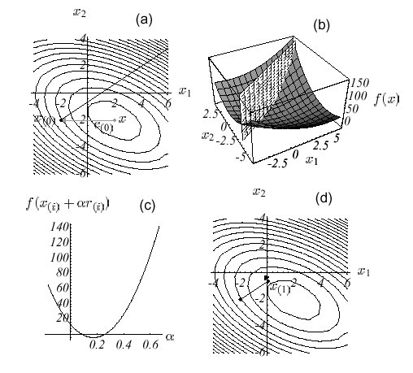
Figure 8. The Method of Steepest Descent. (a) Starting at ${\left[−2,−2\right]}^{T}$, take a step in the direction of steepest descent of f. (b) Find the point on the intersection of these two surfaces that minimizes f. (c) This parabola is the intersection of surfaces. The bottommost point is our target. (d) The gradient at the bottommost point is orthogonal to the gradient of the previous step.
From basis calculus, α minimizes f when the directional derivate $\frac{d}{dα}f(x_{(1)})$ is equal to zero. By the chain rule, $\frac{d}{dα}f(x_{(1)})=f'(x_{(1)})^{T}\frac{d}{dα}x_{(1)}=f'(x_{(1)})^{T}r_{(0)}$. Setting this expression to zero, α should be chosen so that $r_{(0)}$ and $f'(x_{(1)})$ are orthogonal (see Figure 8(d)).

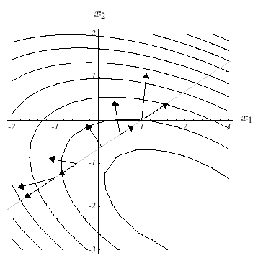
Figure 9. The gradient f- is shown at several locations along the search line (solid arrows). Each gradient's projection onto the line is also shown (dotted arrows). The gradient vectors represent the direction of steepest increase of f, and the projections represent the rate of increase as one traverses the search line. On the search line, f is minimized where the gradient is orthogonal to the search line.

There is an intuitive reason why these vectors should be expected to be orthogonal at the minimum. Figure 9 shows the gradient vectors at various points along the search line. The slope of the parabola (Figure 8(c)) at any point is equal to the magnitude of the projection of the gradient onto the line (Figure 9, dotted arrows). These projections represent the rate of increase of f as one traverses the search line. f is minimized where the projection is zero; where the gradient is orthogonal to the search line.

To determine α, note that $f'(x_{(1)})=−r_{(1)}$, and
$$\begin{aligned} r_{{(1)}^{T}}r_{(0)}=0 \\ (b−{\text{Ax}}_{(1)})^{T}r_{(0)}=0 \\ (b−A(x_{(0)}+{αr}_{(0)}))^{T}r_{(0)}=0 \\ (b−{\text{Ax}}_{(0)})^{T}r_{(0)}−α({\text{Ar}}_{(0)})^{T}r_{(0)}=0 \\ (b−{\text{Ax}}_{(0)})^{T}r_{(0)}=α({\text{Ar}}_{(0)})^{T}r_{(0)} \\ r_{{(0)}^{T}}r_{(0)}={αr}_{{(0)}^{T}}({\text{Ar}}_{(0)}) \\ α=\frac{r_{{(0)}^{T}}r_{(0)}}{r_{{(0)}^{T}}{\text{Ar}}_{(0)}}\end{aligned}$$

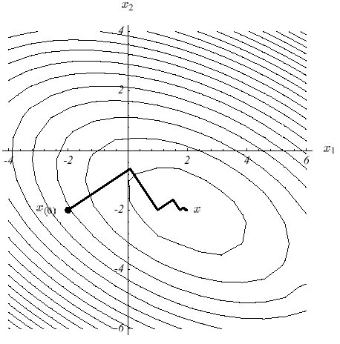
Figure 10. Here, the method of Steepest Descent starts at ${\left[−2,−2\right]}^{T}$ and converges at ${\left[2,−2\right]}^{T}$
Putting it all together, the method of Steepest Descent is:

Eq $r_{(i)}=b−{\text{Ax}}_{(i)},$

Eq $α_{(i)}=\frac{r_{{(i)}^{T}}r_{(i)}}{r_{{(i)}^{T}}{\text{Ar}}_{(i)}},$

Eq $x_{(i+1)}=x_{(i)}+α_{(i)}r_{(i)}\text{.}$
The example is run until it converges in Figure 8. Note the zigzag path, which appears because each gradient is orthogonal to the previous gradient.

The algorithm, as written above, requires two matrix-vector multiplications per iteration. The computational cost of Steepest Descent is dominated by matrix-vector products; fortunately, one can be eliminated. By premultiplying both sides of Eq by -A by and adding b, it gives the following equation

Eq $r_{(i+1)}=r_{(i)}−α_{(i)}{\text{Ar}}_{(i)}$

Although Eq is still needed to compute $r_{(0)}$, Eq can be used for every iteration thereafter. The product Ar, which occurs in both Eq and Eq , need only be computed once. The disadvantage of using this recurrence is that the sequence defined by Eq is generated without any feedback from the value of $x_{(i)}$, so that accumulation of floating point roundoff error may cause $x_{(i)}$ to converge to some point near x. This effect can be avoided by periodically using Eq to recompute the correct residual.
    - The method of Conjugate Gradients
The complete method of Conjugate Gradients is:
Eq $d_{(0)}=r_{(0)}=b−{\text{Ax}}_{(0)},$
Eq $α_{(i)}=\frac{r_{{(i)}^{T}}r_{(i)}}{d_{{(i)}^{T}}{\text{Ad}}_{(i)}}$
Eq $x_{(i+1)}=x_{(i)}+α_{(i)}d_{(i)},$
Eq $r_{(i+1)}=r_{(i)}−α_{(i)}{\text{Ad}}_{(i)},$
Eq $β_{(i+1)}=\frac{r_{{(i+1)}^{T}}r_{(i+1)}}{r_{{(i)}^{T}}r_{(i)}},$
Eq $d_{(i+1)}=r_{(i+1)}+β_{(i+1)}d_{(i)}\text{.}$
And pseudocode:
$\begin{aligned}i⇐0 \\ r⇐b−\text{Ax} \\ d⇐r \\ δ_{\text{new}}⇐r^{T}r \\ δ_{0}⇐δ_{\text{new}} \\ \text{while} i<i_{\text{max}} \text{and} δ_{\text{new}}>ε^{2}δ_{0} \text{do} \\ q⇐\text{Ad} \\ α⇐\frac{δ_{\text{new}}}{d^{T}q} \\ x⇐x+αd \\ \text{If} i \text{is} \text{divisible} \text{by} \text{50} \\ r⇐b−\text{Ax} \\ \text{else} \\ r⇐r−αq \\ δ_{\text{old}}⇐δ_{\text{new}} \\ δ_{\text{new}}⇐r^{T}r \\ β⇐\frac{δ_{\text{new}}}{δ_{\text{old}}} \\ d⇐r+βd \\ i⇐i+1\end{aligned}$

- n-frame interpolation
  - Algorithm
The model presented by [] involves several numerical methods for solving different mathematical problems, and implies very computationally intensive algorithms. The processing bottleneck in this model is by no doubt the simulation part, not the visualization. Based on this fact, the proposed technique targets to reduce the CPU time spent in simulation code. The basic idea is very intuitive and relatively easy to implement: the density of all voxels are linearly interpolated for a specified number n of intermediate frames between the frames with full simulation. Compared to the processing time for a full simulation, the requirement for linearly interpolating the densities is close to zero; hence increasing the framerate with a factor n.

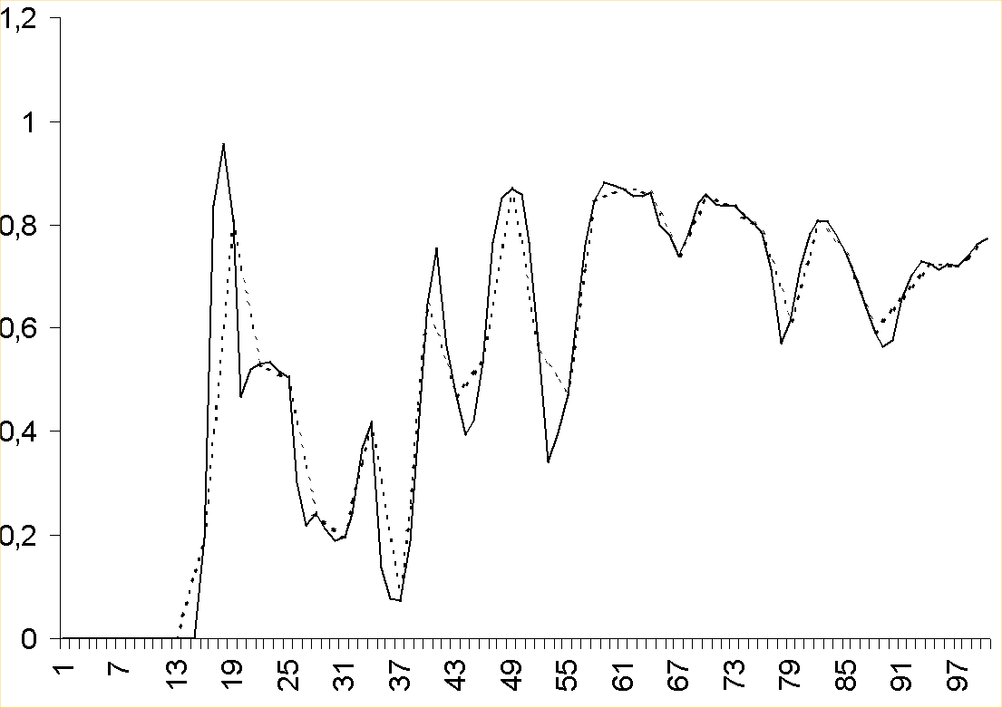
Figure 11. 3-frame approximation of a voxel's density for each frame in a 100 frame simulation.

Figure 11 illustrates the approximation with n = 3, and the density for a spesific voxel in the domain is rendered over time. The black line describes values sampled from a full simulation, while the dotted line illustrates how linear interpolation would approximate this voxel's value. With n = 3, two intermediate frames are calculated for each full simulation frame, reducing the processing time required for each frame to about one third of the original. When interpolating densities for a given frame, the next frame to be fully simulated must be known ahead of time. E.g. in the case of 3-frame interpolation (as in Figure 11), every third frame will run a full simulation while the two intermediate frames are interpolated. Given a simulation starting with full simulation at frame 0, frames 1 and 2 will be interpolated. To perform linear interpolation of frame 1 and 2, both frame 0 and frame 3 has to be known at the time of interpolation. Hence frame 3 has to be known already at frame 1; while it's still in the future. Pseudocode for the algorithm:

- i = 0
- n = 3
- Calculate densities for frame[0]
- if (i % n == 0)
- Calculate densities for frame[i + n]
- Render frame[i]
- else
- k = (i % n)/n
- Render (1-k)*frame[i-(i%n)] + k*frame[i-(i%n)+n]
- i = i + 1
- goto 4

This pseudocode would produce a visually correct animation, but it will not be able to keep a steady and smooth output of frames. This effect is caused by the full simulation frames performed every nth frame, making these frames considerably slower to process than the intermediate frames. The result is an animation that delays noticeably at every nth frame, hence an unacceptable situation. By dividing the processing for each full simulation frame into n sections, every frame would perform the same amount of processing work.

Figure 12. Illustration of processing requirements with 3-frame interpolation.

Figure 12 shows how the different frames must be known at different frames. The top row defines the animation's time/frame, the bottom row what will be rendered that specific frame. At frame 0, 3 and 6, the exact calculated frame will be rendered. At frame 1, 2, 4, 5, 7 and 8, interpolated data will be rendered. The gray fields illustrates what data has to be known at the different frames. At frame 0, full simulation data for both frame 0 and frame 3 are completed (in other words; they are calculated before the animation starts). The calculation of frame 6 also starts here, and completes about one third of it's required processing. At frame 1, all densities rendered are a result of blending 66.6% of frame 0 with 33.3% of frame 3 (standard linear interpolation). The computation for frame 6 continues, and two thirds of it's required processing is now done. At frame 2, densities are rendered by blending 33.3% of frame 0 with 66.6% of frame 3, and frame 6 completes it's calculations. The cycle ends and restarts at frame 3. Here the exact data from frame 3 are used as source for rendering, frame 0 are removed from the "stack" and calculations for frame 9 starts.
  - Limitations
The visual success of this optimization technique relies heavily on the methods of integration and advection used in the advection step. To compute intermediate frames by interpolation, larger timesteps are required for the full simulation frames, and as the timesteps increase, the integration/advection methods looses accuracy. The trapezoidal method described in section 2.2.2 produces significant errors if few iterations are performed and/or the timesteps cover great numerical variations in the function. Several more accurate methods exist, often involving more iterations and higher order of accuracy for the initial guess. Each iteration initiates the interpolating of different values, and unfortunately the calculation of these values represents the main source of processing in the prototype. Hence, the speedup gained by using n-frame interpolation could very well be lost by using more accurate integration methods. The timesteps are also limited by another aspect: the rate of change in the smoke. If large forces are introduced, the particles will obtain great velocities and the smoke's configuration will change rapidly over time. To capture these variations, either sufficiently small timesteps or very accurate integration/advection methods are necessary.

Potential problems may also be introduced when unpredictable forces influence the smoke's configuration, for example in interactive applications. The nature of the n-frame interpolation method needs a predictable future to be able to calculate frames in advance. This problem could simply be solved by ignoring it. If a user suddenly activates a force in the smoke's domain, one could simply delay the effect of this action as much as needed. Using the 3-frame interpolation example as illustration, a maximum of 6 (2n) frames delay could occur. For example; if the force is activated right after frame 0 is done rendered, the force cannot be included until the simulation of frame 9 starts (frame 6 have already started processing). The simulation results at frame 9 will affect rendering from frame 6, giving a maximum delay of 6 frames. This is the absolute worst case. If the force is activated right after rendering of frame 2, a delay of only 3 (n) frames is experienced. The amount of delay is hence dependent on the choice of n, where greater n results in a longer delay.

- Implementation
  - Simulation
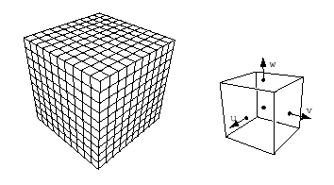
Figure 13. Discretization of the computational domain into identical voxels (left). The components of the velocity are defined on the faces of each voxel (right).

The simulation is performed within a finite volume with spatial discretization to numerically solve the equations of fluid flow. As shown in Figure 13, the computational domain is divided into identical voxels. The temperature, the smoke’s density and the external forces are defined at the center of each voxel, while the velocity is defined on the appropriate voxel faces Figure 13. This arrangement is identical to that of [] and [], compared to others [] which define velocities at the voxels' center as well. [] states that this staggered grid arrangement of the velocity field gives improved results for numerical methods with less artificial dissipation. See Appendix A for more details on the discretization used in the prototype. To handle boundaries immersed in the fluid all voxels intersecting an object is tagged as being occupied, and all occupied voxel cell faces have their velocity set to that of the object. Similarly, the temperature at the center of the occupied voxels is set to the object’s temperature. The smoke’s density is of course equal to zero inside the object.

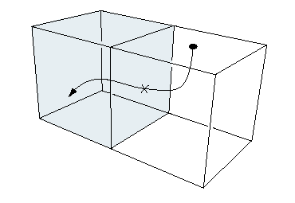
Figure 14. Semi-Lagrangian paths that end up in a boundary voxel are clipped against the boundaries' face.

The solver requires two voxel grids for all physical quantities. The simulation advances by updating one grid from the other over a fixed time step Δt. At the end of each time step these grids are swapped. Pseudocode for the simulation consist of five steps:

- Add forces to velocities
- Solve advection term (Semi-Lagrangian)
- Solve Poisson equations
- Conserve mass by subtracting gradient
- Advect density and temperature (Semi-Lagrangian)

The grid may initially contain some user provided data, but in most cases the grids are simply empty. First the velocity field are updated with the force field. This is done simply by multiplying the force of each voxel with the timestep Δt and adding the result to the voxel's velocity (see Appendix A). The forces include user supplied fields and the buoyancy force defined by Eq . The next step solves for the advection term in Eq , using a Semi-Lagrangian scheme. See [] for a review and [] for its first application in computer graphics. The semi-Lagrangian scheme builds a new grid of velocities from the ones already computed, by tracing the midpoints of each voxel face through the velocity field. New velocities are then linearly interpolated at these points and their values are transferred to the face cells they originated from. It is possible that the point ends up in one of the occupied voxels, where the path simply is clipped against the voxel boundary as shown in Figure 14. This guarantees that the point always lies in the unoccupied fluid. Simple linear interpolation is easy to implement, gives satisfactory results and is unconditionally stable as it never overshoots data. Higher order interpolation schemes are, however, desirable in some cases for high quality animations. Unfortunately, usually these schemes overshoot the data which results in instabilities. Also, as this prototype aims for a realtime environment, the processing cost of higher order interpolation is considered not worth the effort.

Finally the velocity field is forced to conserve mass. As already stated in section 2.1, this involves the solution of a Poisson equation for the pressure (Eq ). The discretization of this equation results in a sparse linear system of equations. Free Neumann boundary conditions are imposed at the occupied voxels by setting the normal pressure gradient equal to zero at the occupied boundary faces. The system of equations is symmetric, and the most natural linear solver in this case is the Conjugate Gradient method (CG). CG is easy to implement and has much better convergence properties than simple relaxation methods. The algorithm and pseudocode are both presented in section 2.4.4. It terminates when the maximum number of iterations imax has been executed, or when the error crawls below the error tolerance ε. The method of CG is an iterative algorithm, solving linear sets of equations like Ax = b and each iteration involves a matrix multiplication with A and a vector. A computational domain diced into $n×n$ identical voxels would produce a set of $n^{4}$ equations, hence a matrix with $N^{4}$ elements. The five-point formula makes A a sparse matrix with very predictable structure, thus leaving the possibility of creating an extremely effective multiplication routine:

void Smoke2D::FastMul(float *pafX, float *pafResult)
{
int k = 0;
for (int j = 0; j < m_nYSize; j++)
{
for (int i = 0; i < m_nXSize; i++)
{
pafResult[k] = -4.0f*pafX[k];
if (i != 0)
pafResult[k] += 1.0f*pafX[k - 1];
if (i != m_nXSize - 1)
pafResult[k] += 1.0f*pafX[k + 1];
if (j != 0)
pafResult[k] += 1.0f*pafX[k - m_nXSize];
if (j != m_nYSize - 1)
pafResult[k] += 1.0f*pafX[k + m_nXSize];
k++;
}//for
}//for
}//FastMul

This function multiplies matrix A with the vector pafX and saves the result in pafResult. Note that A never exists as an in-memory structure but is generated on the fly. Even with clever memory organization of sparse matrices, a structure keeping a $\text{10000}×\text{10000}$ matrix of floatingpoint values could easily occupy 600k of memory. This forces traversal of huge memory blocks for each CG iteration, thus rendering the processor's internal cache unusable. As memory is a major bottleneck of todays' systems, any algorithm managing to avoid intensive use of memory would gain a significant speedup compared to those who don't. The prototype showed that about 10 iterations of this solver produce acceptable visual results, and represents only approximately 15% of the processing time required for a full simulation frame.

After the pressure is computed, its gradient is subtracted from the velocity (see appendix A for the exact discretization of the operators involved). After the velocity is updated, both the temperature and the smoke’s density are advected again solving the equations by using a semi-Lagrangian scheme. In this case, however, the centers are traced instead of the voxel's faces. The interpolation scheme is similar to the velocity case.
  - Rendering
Displaying a voxel grid in two dimensions is quite a trivial matter, and the prototype's renderer is a very straight forward implementation: The result of the computations are visualized by drawing a series of OpenGL quads where each vertex represents a voxel's density.

- Results
This section contains several examples of smoke simulations. All simulations have been run on a AMD Duron-800 with an NVidia Geforce 2 MX video card.

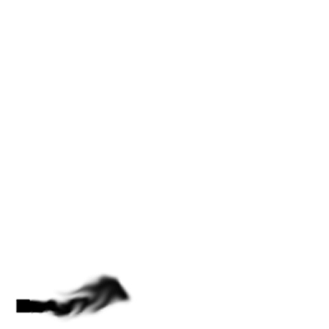 | 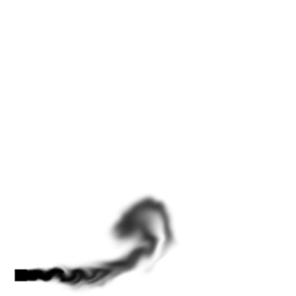 | 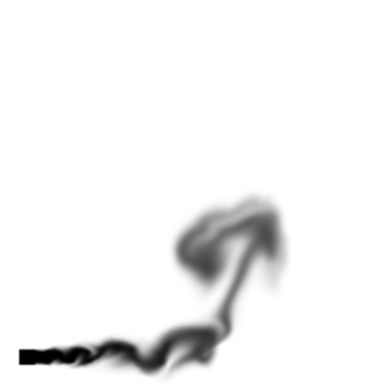
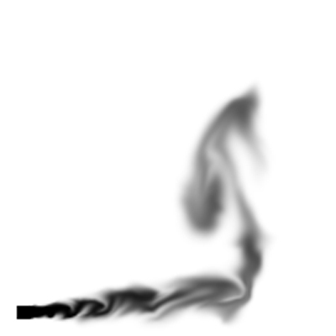 | 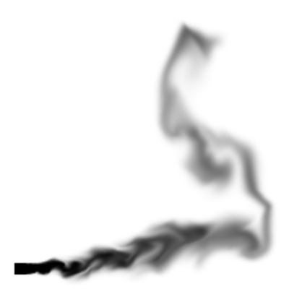 | 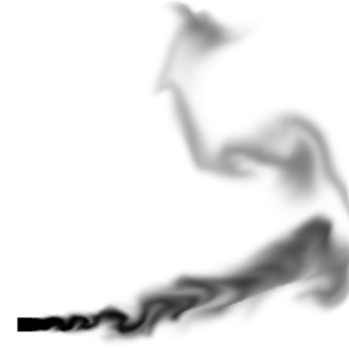
Figure 15. Stills from the prototype. Hot smoke rising (exact, 200x200, 2.5 fps)
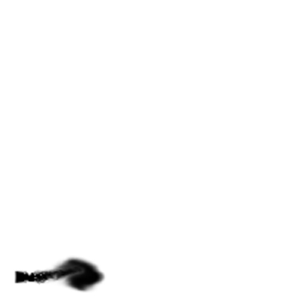 | 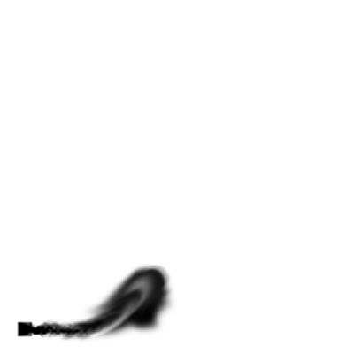 | 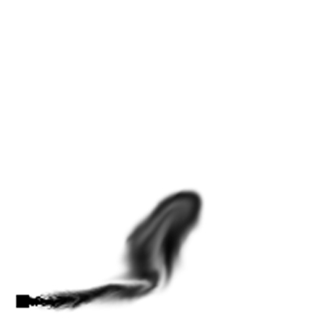
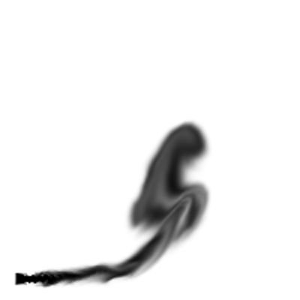 | 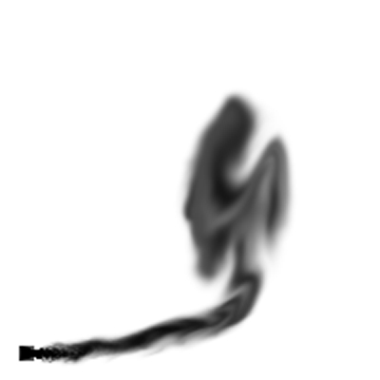 | 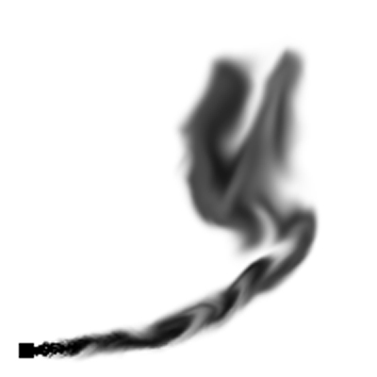
Figure 16. Stills from the prototype. Hot smoke rising (3-frame interpolation, 200x200, 5.6 fps)
Figure 15 shows a standard simulation of hot smoke rising on a 200x200 grid, without any interaction with objects. This is an exact simulation without any n-frame interpolation, and the timestep is 0.08s. The smoke is given an initial horisontal speed, while all vertical forces are a result of the buoyance force. Figure 16 demonstrates how the 3-frame interpolation works with the same initial configuration as in Figure 15. The timestep for the keyframes (full/exact simulation frames) is now increased to 0.24s, with two intermediate frames for each frame of full simulation. Figure 17 compares another exact simulation (left column) with a 2-frame interpolated simulation (right column).

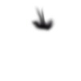 | 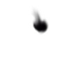
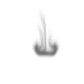 | 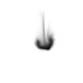
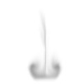 | 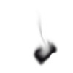
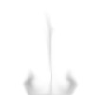 | 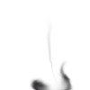
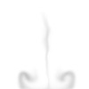 | 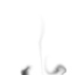
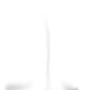 | 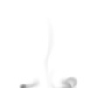

Figure 17. Left: exact, 100x100, 12 fps. Right: 2-frame interpolation, 100x100, 24fps

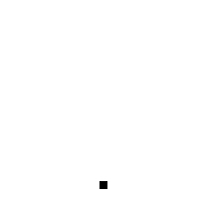
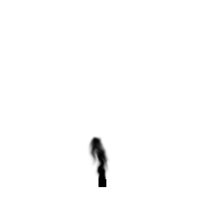 | 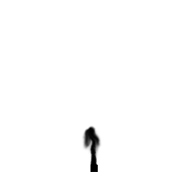
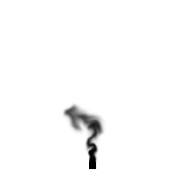 | 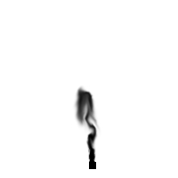
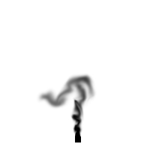 | 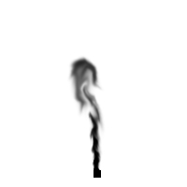
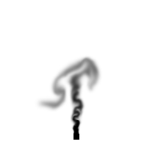 | 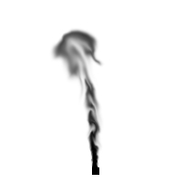
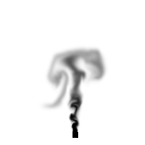 | 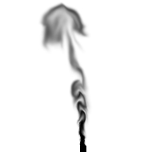
Figure 18. Exact animations. a) (left) frame 0, 50, 100, 150, 200 and 250. Timestep 0.04s. b) (right) Frame 0, 25, 50, 75, 100, 125. Timestep 0.08s.
- Conclusion
  - Visual results
Figure 15, Figure 16 and Figure 17 presents a visual comparison of the original model with the technique presented in this paper. Obviously, the two versions does not produce exactly the same visual result, as both examples shows. The difference is mainly caused by different timesteps in the advection and integration, not the n-frame interpolation itself. This is demonstrated by Figure 18, where two different exact simulations are compared. Figure 18a) shows an exact simulation with timestep 0.04s while Figure 18 b) shows an exact simulation with timestep 0.08s. Figure 18 a) produces twice as many frames for one second of animation than b). In an ideal world, every 2n frame in a) would be a perfect match with frame n in b), but unfortunately, due to the different numerical methods used, this is not the case. The advection step is solved through SLSI methods (Section 2.2) and uses the trapezoidal method to obtain the departure point of the trajectory. Then linear interpolation and simple numerical integration is performed to calculate the actual values to be transported. All these steps introduce a numerical error dependent on Δt, hence the difference between the two animation strips. This fact makes it hard to calculate the actual numerical error introduced by n-frame interpolation, as it is impossible to generate data for comparison. For example, if an exact simulation with timestep 0.1s were to be optimized with 2-frame interpolation, keyframes had to be generated with Δt = 0.2s. This variation in timestep itself introduces a difference so that the interpolated frames end up approximating a different graph than the original simulation.

The original purpose of this technique is to produce credible visual results, not physically accurate results for real simulations. As long as the audience experience the animation as live smoke rolling, the optimization technique is from a visualizing point of view, a success.

The current prototype is implemented using the pseudocode described in section 3.1. The problem stated in section 3.1 regarding smooth animations therefore applies to this prototype.
  - Optimization results
As for the optimization point of view, the technique performs approximately as expected. The computation cost of linearly interpolating i.e. 100x100 values scales to approximately zero compared to the cost of fully simulating 100x100 values. That gives the simulationcode approximately a speedup of factor n for n-frame interpolation. The total speedup depends heavily on the computational relationship between simulationcode and visualizationcode. The n-frame optimization is based on the simulationcode being the main bottleneck. Profiling shows that about 95% of the processing time is spent in simulation code, thus giving a great potential for optimizations. Figure 15 and Figure 16 simulate the same initial configuration, where 3-frame interpolation gives a speedup from 2,5 fps to 5,6 fps. This is a speedup of 2.24, a little less than n. This is expected, as finer grids require more processing for linear interpolation and rendering of the intermediate frames.

The total computational cost of fully simulating and rendering a frame is

Eq $t_{\text{exact}}=t_{\text{simulation}}+t_{\text{rendering}}$.

And an animation with f frames would require

Eq $t_{{\text{exact}}_{\text{animation}}}(f)={\text{ft}}_{\text{full}}$

The cost of an intermediate frame with n-frame interpolation is

Eq $t_{\text{int}\text{erpolated}}=t_{\text{int}\text{erpolation}}+t_{\text{rendering}}$.

For any n-frame interpolated animation, frame 0 is calculated in advance of the realtime loop and does not affect the fps. An exact animation with $f=\text{kn}, k ε N_{1}$ frames gives from Eq and Eq a total processing time

$t_{{\text{exact}}_{\text{animation}}}(\text{kn})={\text{knt}}_{\text{exact}}+{\text{knt}}_{\text{rendering}}$.

n-frame interpolation requires fully simulated keyframes only at every nth frame. The remaining frames are interpolated. This gives a total time of

$t_{\text{int}{\text{erpolated}}_{\text{anim}}}(\text{kn})$ $={\text{kt}}_{\text{exact}}+(n−1){\text{kt}}_{\text{int}\text{erpolated}}$
$={\text{kt}}_{\text{simulation}}+(n−1){\text{kt}}_{\text{int}\text{erpolation}}+{\text{knt}}_{\text{rendering}}$

Compared to simulation and rendering, the time spent in interpolation grows to zero and may be dropped from the equation.

$$t_{\text{int}{\text{erpolated}}_{\text{anim}}}(\text{kn})≈{\text{kt}}_{\text{simulation}}+{\text{knt}}_{\text{rendering}}$$

The speedup is

$\text{speedup}=\frac{t_{{\text{exact}}_{\text{animation}}}(\text{kn})}{t_{\text{int}{\text{erpolated}}_{\text{anim}}}(\text{kn})}≈\frac{{\text{knt}}_{\text{simulation}}+{\text{knt}}_{\text{rendering}}}{{\text{kt}}_{\text{simulation}}+{\text{knt}}_{\text{rendering}}}$,

which explains the results presented in Figure 15, Figure 16 and Figure 17; a speedup of approximately n can be expected as long as the time spent in rendering code is sufficiently small compared to the simulation code.
    - Future work
An obvious extension of the prototype is to move from two to three dimensions. This introduces more complicated data structures and rendering, while the simulation code stays more or less the same. The linear interpolation of off-grid values will involve eight reference points instead of four, and the matrix built for solving Poisson equations will of course grow accordingly to the extra dimension. The relationship between rendering and simulation will also change as the model is extended to three dimensions. More processor intensive calculations are suddenly required to render the results, especially in respect to lighting. A very important aspect when rendering volumes of smoke is the effect of self-shadowing. This can for example be achieved by using a fast Bresenham line drawing voxel traversal algorithm [] to trace rays of light through the volume.

The smooth flow problem stated in section 3.1 needs further research to be solved satisfactory. Section 3.1 suggests a theoretical solution, but the task of dividing the simulation into n blocks with identical computational cost is not trivial.

As for further optimization, approaches such as n-frame self-advection should be investigated. More accurate integration and advection schemes should also be researched in order to defeat the numerical dissipation and the smoke's rolling mechanics "dying out" too fast.

Appendix A Discretization
The space is diced into $N^{3}$ voxels with uniform spacing h. The temperature and the smoke’s density are both defined at the voxel centers and denoted by $T_{i,j}$ and $ρ_{i,j}$, $i,j=1,…,N$ respectively. The velocity on the other hand is defined at the cell faces. It is usual in the CFD literature to use half-way index notation for this.

$$\begin{aligned}u_{i+\frac{1}{2},j},i=0,…,N,j=1,…,N \\ u_{i,j+\frac{1}{2}},j=0,…,N,i=1,…,N\end{aligned}$$

Using these notations, some discrete operators can now be defined. The divergence is defined as

$${\left(∇⋅u\right)}_{i,j}=\frac{\left(u_{i+\frac{1}{2},j}−u_{i−\frac{1}{2}}+v_{i+\frac{1}{2},j}−v_{i−\frac{1}{2}}\right)}{h}$$

while the discrete gradients are (note $∇p=(p_{x},p_{y})$)

$$\begin{aligned}{\left(p_{x}\right)}_{i+\frac{1}{2},j}=\frac{\left(p_{i+1,j}−p_{i−1,j}\right)}{h} \\ {\left(p_{y}\right)}_{i,j+\frac{1}{2}}=\frac{\left(p_{i,j+1}−p_{i,j−1}\right)}{h}\end{aligned}$$

The discrete Laplacian is simply the combination of the divergence and the gradient operators.

All the force fields are defined at the center of the grid voxels. To get values at the faces, simply average again. If the force field $f=\left(f^{1},f^{2},f^{3}\right)$, then the velocity is updated as

$$\begin{aligned}u_{i+1,j}=\frac{Δt\left(f_{i,j}^{1},f_{i+1,j}^{1}\right)}{2} \\ u_{i+1,j}=\frac{Δt\left(f_{i,j}^{2},f_{i,j+1}^{2}\right)}{2}\end{aligned}$$
References

[] R. Fedkiw, J. Stam, and H. W. Jensen. Visual Simulation of Smoke. In SIGGRAPH 2001 Conference Proceedings, Annual Conference Series , pages 15-22, August 2001

[] J. Stam. Stable Fluids. In SIGGRAPH 99 Conference Proceedings, Annual Conference Series, pages 121–128, August 1999.

[] N. Foster and D. Metaxas. Realistic Animation of Liquids. Graphical Models and Image Processing, 58(5):471–483, 1996.

[] A. Staniforth and J. Cote. Semi-lagrangian integration schemes for atmospheric models: A review. Monthly Weather Review, 119:2206–2223, 1991.

[] G. Y. Gardner. Visual Simulation of Clouds. Computer Graphics (SIGGRAPH 85 Conference Proceedings), 19(3):297–384, July 1985.

[] K. Perlin. An Image Synthesizer. Computer Graphics (SIGGRAPH 85 Conference Proceedings), 19(3):287–296, July 1985.

[] D. S. Ebert and R. E. Parent. Rendering and Animation of Gaseous Phenomena by Combining Fast Volume and Scanline A-buffer Techniques. Computer Graphics (SIGGRAPH 90 Conference Proceedings), 24(4):357–366, August 1990.

[] G. Sakas. Fast Rendering of Arbitrary Distributed Volume Densities. In F. H. Post and W. Barth, editors, Proceedings of EUROGRAPHICS ’90, pages 519–530. Elsevier Science Publishers B.V. (North-Holland), September 1990.

[] J. Stam and E. Fiume. Turbulent Wind Fields for Gaseous Phenomena. In SIGGRAPH 93 Conference Proceedings, Annual Conference Series, pages 369–376, August 1993.

[] J. T. Kajiya and B. P. von Herzen. Ray Tracing Volume Densities. Computer Graphics (SIGGRAPH 84 Conference Proceedings), 18(3):165–174, July 1984.

[] L. Yaeger and C. Upson. Combining Physical and Visual Simulation. Creation of the Planet Jupiter for the Film 2010. ComputerGraphics (SIGGRAPH 86 Conference Proceedings), 20(4):85–93, August 1986.

[] M. N. Gamito, P. F. Lopes, and M. R. Gomes. Two-dimensional Simulation of Gaseous Phenomena Using Vortex Particles. In Proceedings of the 6th Eurographics Workshop on Computer Animation and Simulation, pages 3–15. Springer Verlag, 1995.

[] N. Foster and D. Metaxas. Modeling the Motion of a Hot, Turbulent Gas. In SIGGRAPH 97 Conference Proceedings, Annual Conference Series, pages 181–188, August 1997.

[] N. Foster and D. Metaxas. Realistic Animation of Liq-uids. Graphical Models and Image Processing, 58(5):471–483, 1996.

[] G. Yngve, J. O’Brien, and J. Hodgins. Animating explosions. In SIGGRAPH 2000 Conference Proceedings, Annual Conference Series, pages 29–36, July 2000.

[] An Introduction to the Conjugate Gradient Method Without the Agonizing Pain Edition. Jonathan Richard Shewchuk, August 4., 1994

[] Robert, A., 1981: A stable numerical integration scheme for the primitive meteorological equations. Atmos. Ocean., 19, 35-46.

[] Pudykiewicz, J., Benoit, R. and Staniforth, A., 1985: Preliminary results from a partial LRTAP model based on an existing meteorological forecast model. Atmos. Ocean, 19, 267-303.

[] Smolarkiewicz, P. K. and Pudykiewicz, J., 1992: A class of semi-Lagrangian approximations for uids. J. Atmos. Sci., 49, 2082-2096.

[] McGregor, J. L., 1993: Economical determination of departure points for semi-Lagrangian models. Mon. Wea. Rev., 121, 221-230.

[] Pudykiewicz, J., and Staniforth, A., 1984: Some properties and comparitive performance of the semi-Lagrangian method of Robert in the solution of the advection-diffusion equation. Atmos. Ocean, 22, 283-308.

[] Bates, J. R. and McDonald, A., 1985: Comments on \Some properties and comparitive performance of the semi-Lagrangian method of Robert in the solution of the advection-diffusion equation". Atmos. Ocean, 23, 193-194.

[] Staniforth, A. and Pudykiewicz, J., 1985: Reply to comments on and addenda to "Some properties and comparitive performance of the semi-Lagrangian method of Robert in the solution of the advection- diffusion equation". Atmos. Ocean, 23, 195-200.

[] Gear, C. W., 1971: Numerical Initial Value Problems in Ordinary Differential Equations, Prentice-Hall, New Jersey.

[] Temperton, C. and Staniforth, A., 1987: An efficient two-time-level semi-Lagrangian semi-implicit integration scheme. Q. J. R. Meteorol. Soc., 113, 1025-1039.

[] Staniforth, A. and Côtè, J. 1991: Semi-Lagrangian integration schemes for atmospheric models - a review. Mon. Wea. Rev., 119, 2206-2223.

[] Malevsky, A., 1996: Spline-characteristic methods for simulation of convective turbulence. J. Comput. Phys, 123, 466-475.

[] J. D. Fowley, A. van Dam, S. K. Feiner, and J. F. Hughes. Computer Graphics: Principles and Practice. Second Eidtion. Addison-Wesley, Reading, MA, 1990.

